# PyTorch

查看NVIDIA GPU驱动版本

watch -n1 nvidia-smi

查看CUDA toolkit

nvcc -v

conda update conda

conda update anaconda

conda update python

conda update --all

conda config --add channels <https://mirrors.tuna.tsinghua.edu.cn/anaconda/pkgs/free/>

conda config --add channels https://mirrors.tuna.tsinghua.edu.cn/anaconda/pkgs/main/

conda config --add channels https://mirrors.tuna.tsinghua.edu.cn/anaconda/cloud/pytorch/

conda config --add channels https://mirrors.tuna.tsinghua.edu.cn/anaconda/cloud/conda-forge/

conda config --add channels https://mirrors.tuna.tsinghua.edu.cn/anaconda/cloud/msys2/

conda config --set show_channel_urls yes

conda config --remove channels https://mirrors.tuna.tsinghua.edu.cn/anaconda/cloud/conda-forge/

conda config --show

conda create –n pytorch python=3.6

conda activate pytorch

conda deactivate pytorch

conda install pytorch torchvision torchaudio cudatoolkit=10.2 –c pytorch

python

import torch

print('gpu:', torch.cuda.is_available())

pip install tensorflow_gpu-1.15.0-cp37-cp37m-win_amd64.whl

# Sekiro

conda create –n sekiro python=3.7

conda activate sekiro

查看tensorflow-gpu与cuda的适配版本

<https://tensorflow.google.cn/install/source?hl=en#linux>

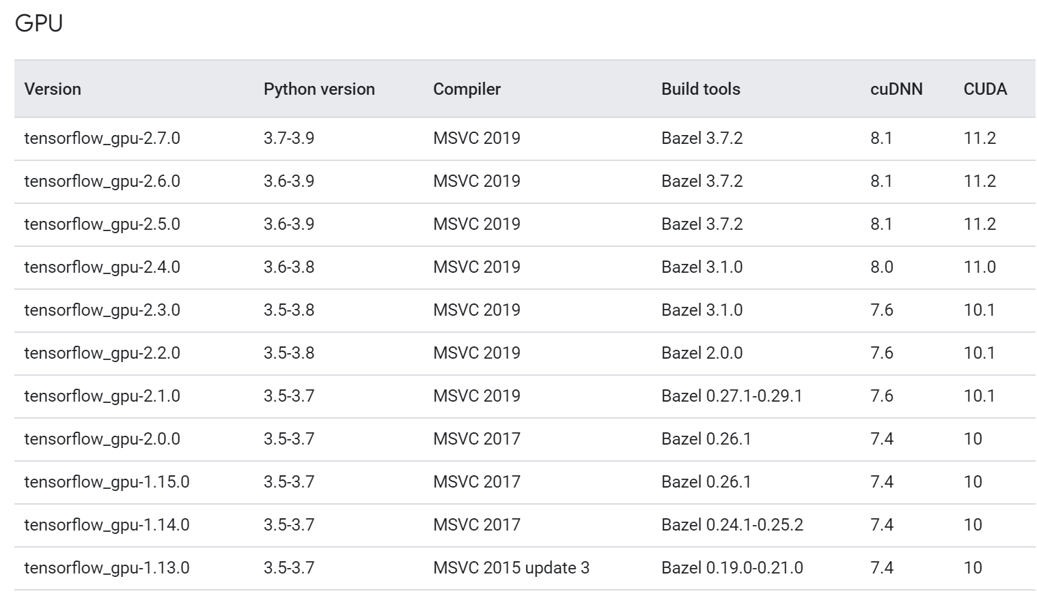

CUDA 10.2

cuDNN 7.6

conda search tensorflow-gpu

conda install tensorflow-gpu=2.3.0 –y

conda install opencv=4.5.3

conda install pillow

conda install pywin32

conda install gym=0.18.0

conda install flask

conda install pyautogui

Pytorch找不到caffe2_detectron_ops.dll

pip install intel-openmp

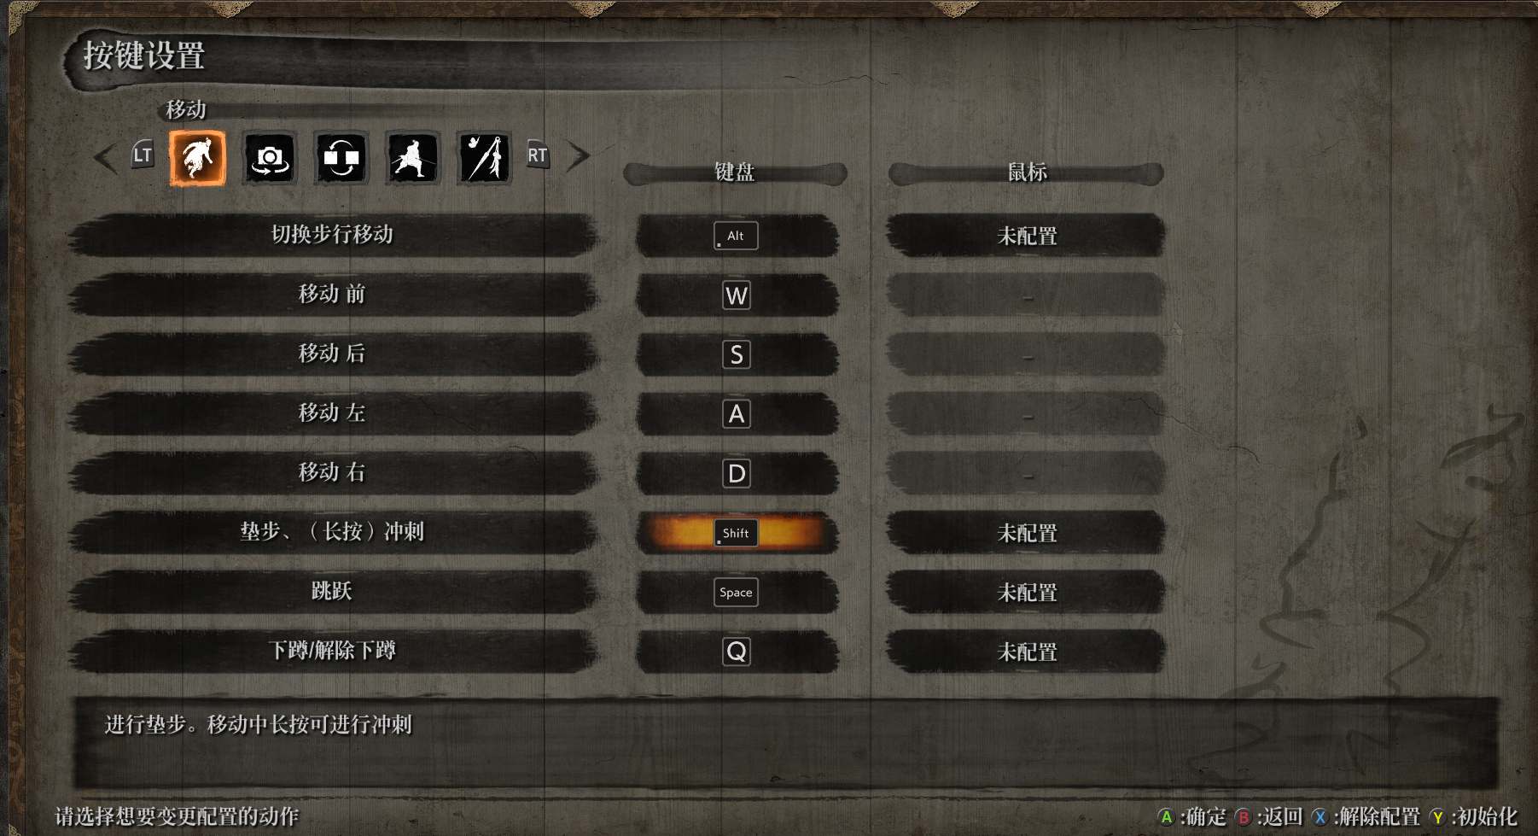

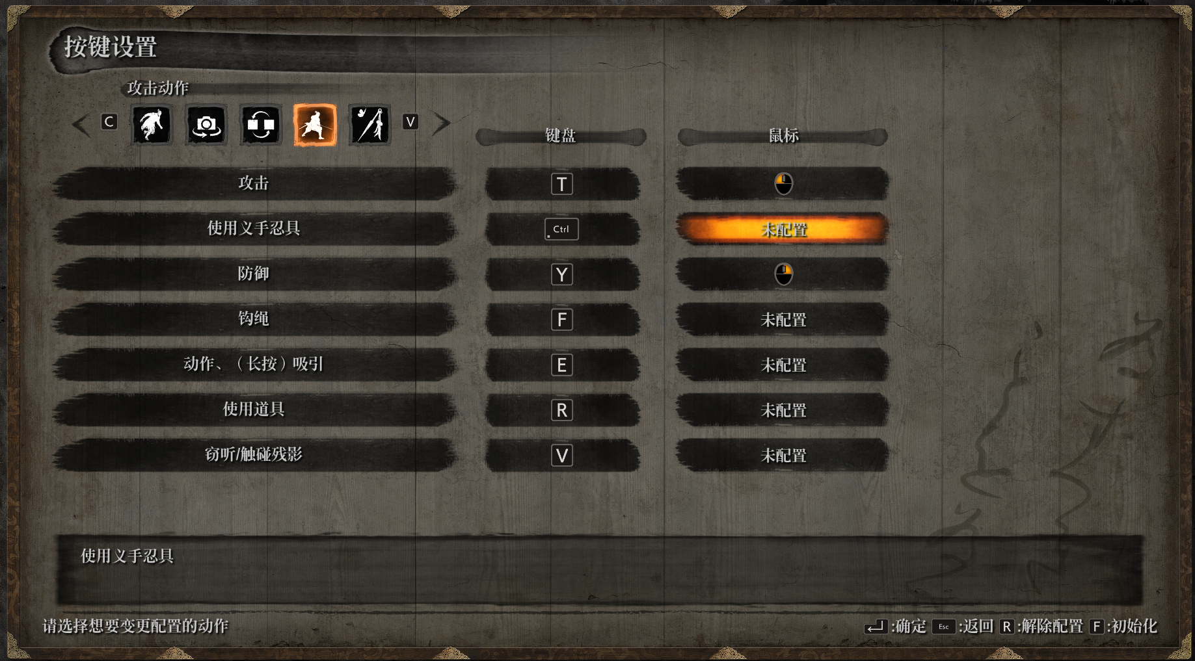

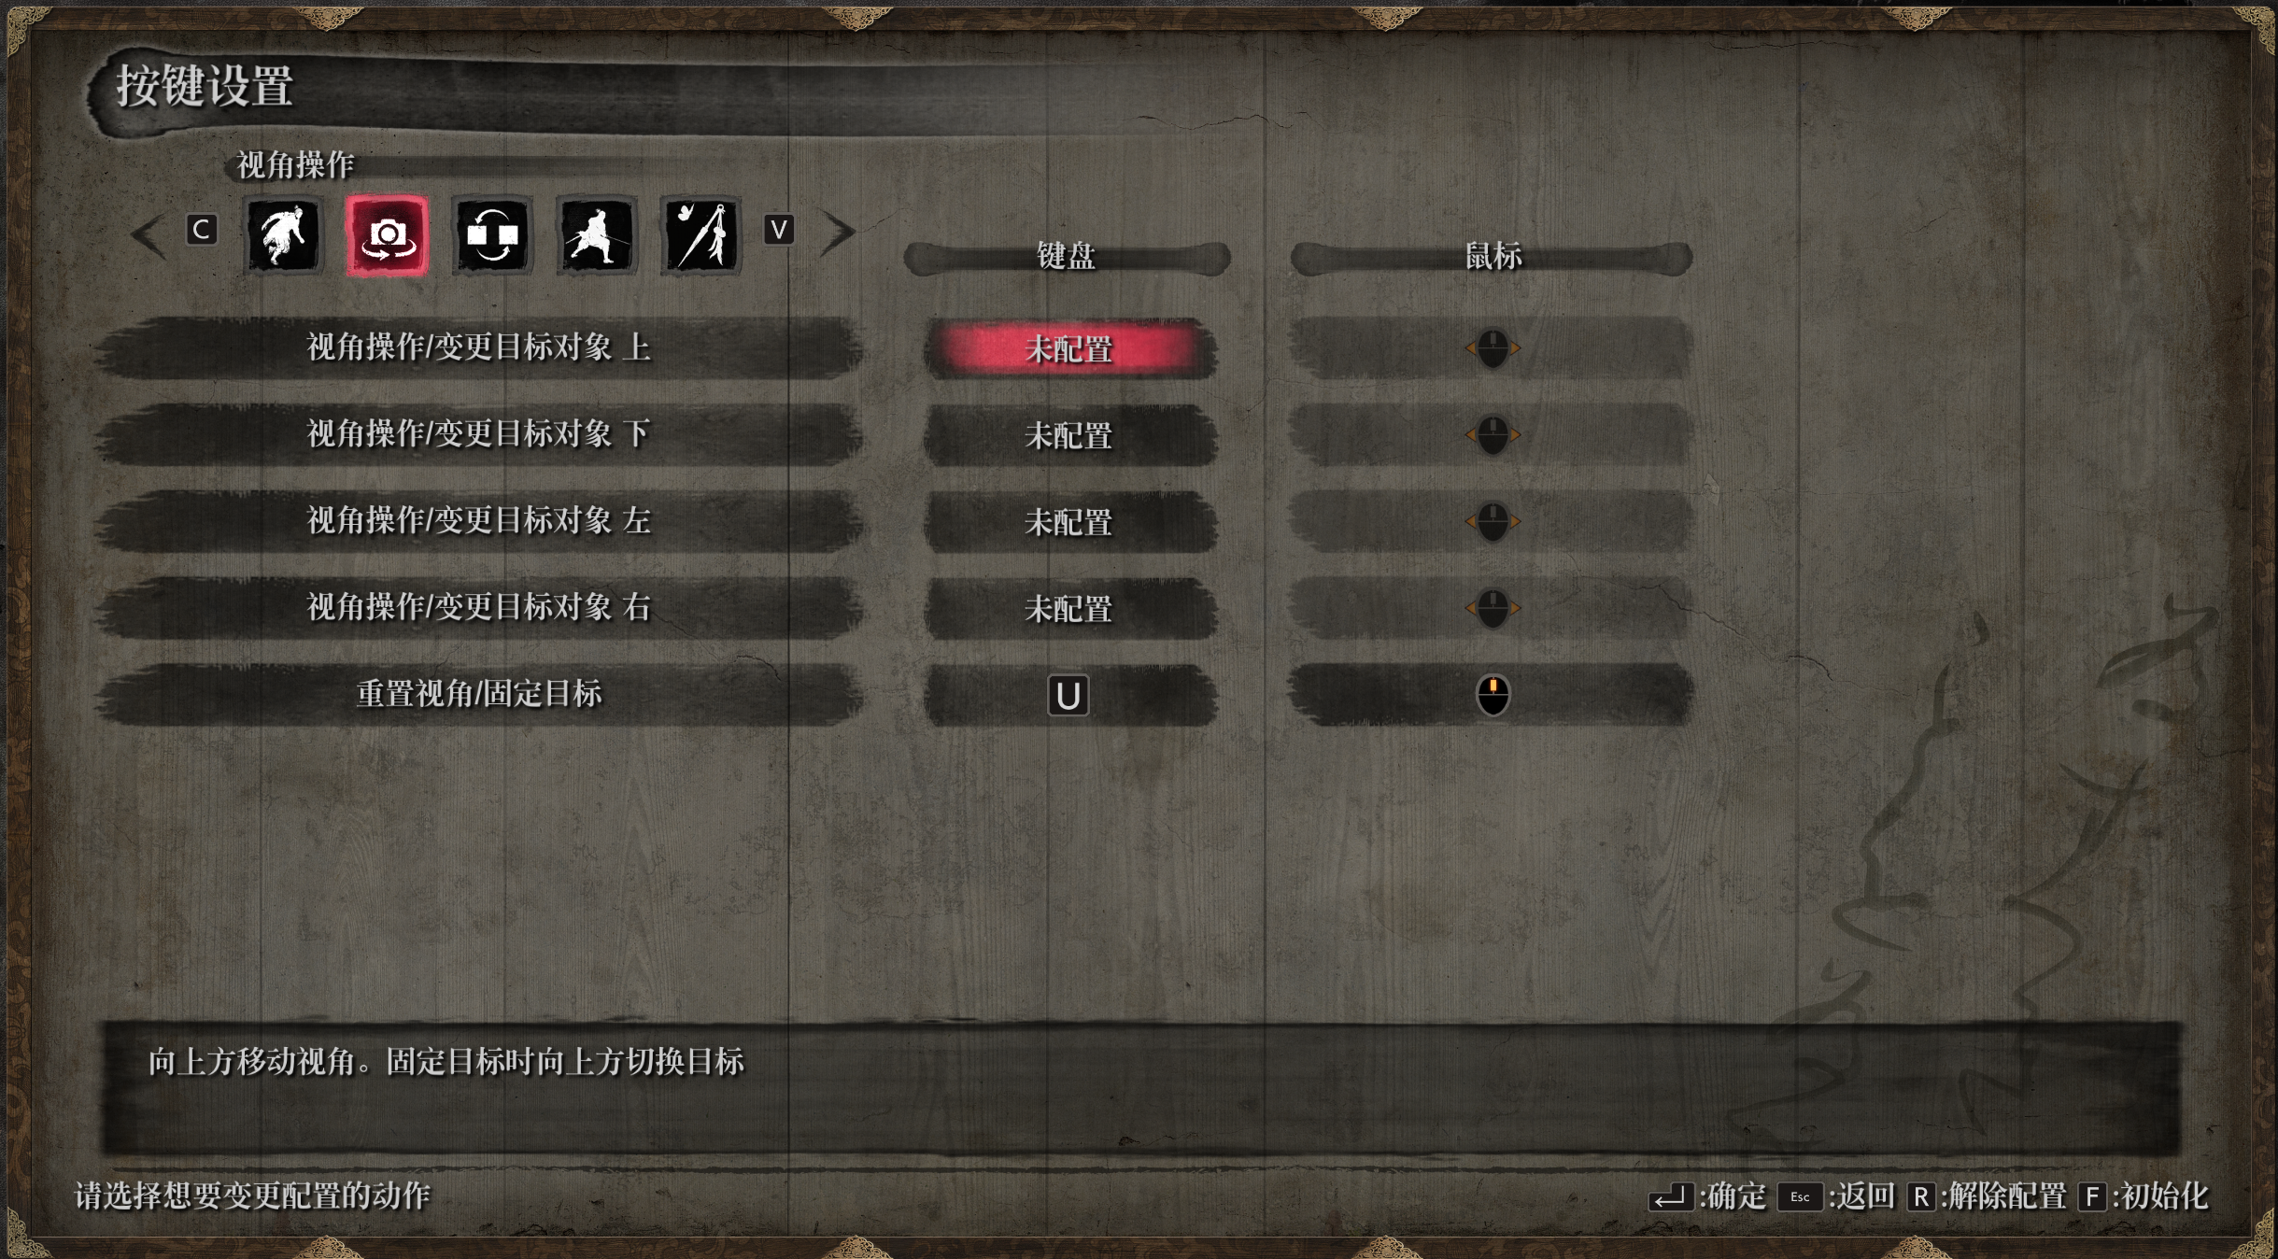

存档文件位于

C:\Users\Administrator\AppData\Roaming\Sekiro

## Troubleshooting

在运行具有使用tensorflow 2.0的代码的kubeflow管道时。在每个时期结束时显示以下错误

W tensorflow / core / kernels / data / generator_dataset_op.cc：103]最终确定GeneratorDataset迭代器时发生错误：已取消：操作已取消

另外，在某些时期之后，它不显示日志并显示此错误

该步骤处于失败状态，并显示以下消息：节点资源不足：内存。容器主容器正在使用100213872Ki，它超出了其0的请求。容器等待正在使用25056Ki，它超出了其0的请求。

这是由于不兼容的CUDA和Tensorflow版本。以下版本相互配合良好

张量流gpu == 2.0.0

tensorflow-addons == 0.6.0

NVIDIA / CUDA：10.0-cudnn7-运行时

## [Linux下为python3安装opencv](https://www.cnblogs.com/yangruicvpr/p/9578947.html)

1.到opencv官网<https://opencv.org/releases.html>下载需要的opencn安装包，如opencv-3.4.2，解压

unzip opencv-3.4.2.zip

2.进入该文件夹

   cd opencv-3.4.2

3.建立文件夹release

 mkdir release

4.安装依赖

   sudo apt-get install build-essential cmake libgtk2.0-dev pkg-config python-dev python-numpy libavcodec-dev libavformat-dev libswscale-dev

5.进入release并编译

   cd release

   cmake -D CMAKE_BUILD_TYPE=RELEASE -D CMAKE_INSTALL_PREFIX=/usr/local ..

6.安装

  sudo make install

conda install requests

conda install beautifulsoup4

conda install tqdm

conda install pandas

conda install matplotlib

pip3 install jieba

pip3 install wordcloud

fc-list :lang=zh查看mac字体

# Pandas解决csv中文乱码问题

Python保存csv文件使用utf-8编码后使用excel打开中文会乱码

使用pandas的read_csv读取后再用to_csv保存文件并设置“encoding=utf_8_sig”即可解决

import pandas as pd

path = ’report_utf8.csv’

data = pd.read_csv(path,)

data.to_csv(‘result_utf8_with_bom.csv’, encoding=’utf_8_sig’)

# Python直接控制鼠标键盘

之前因为期末的原因已经很久没写博客了，今天博主发现一个好玩的模块PyAutoGUI，借助它可以使用Python脚本直接控制键盘鼠标，感觉可以解决很多无聊的机械运动。这里记录一下学习情况

## 安装

$ sudo pip install pyautogui

安装的依赖包可能比较多，只要耐心等待即可

## 基本使用

screenWidth, screenHeight = pyautogui.size() # 屏幕尺寸

mouseX, mouseY = pyautogui.position() # 返回当前鼠标位置，注意坐标系统中左上方是(0, 0)

为了保持用户可以随时干预鼠标键盘的动作，比较好的方法是添加停顿，或者强制结束，否则想停了鼠标还一直在晃就会失控，下面是两种对应的设置

pyautogui.PAUSE = 1.5 # 每个函数执行后停顿1.5秒

pyautogui.FAILSAFE = True # 鼠标移到左上角会触发FailSafeException，因此快速移动鼠标到左上角也可以停止

## 鼠标操作

### 移动

w, h = pyautogui.size()

pyautogui.moveTo(w/2, h/2) # 基本移动

pyautogui.moveTo(100, 200, duration=2) # 移动过程持续2s完成

pyautogui.moveTo(None, 500) # X方向不变，Y方向移动到500

pyautogui.moveRel(-40, 500) # 相对位置移动

### 拖动

# 点击+向下拖动

pyautogui.click(941, 34, button='left')

pyautogui.dragRel(0, 100, button='left', duration=5)

### 点击

pyautogui.click(300, 400, button='right') # 包含了move的点击，右键

pyautogui.click(clicks=2, interval=0.25) # 双击，间隔0.25s

### 滚轮

pyautogui.scroll(-10)

## 键盘操作

### 输入文字

点击对话框输入文字即可，不过中文好像不行

pyautogui.click(1279, 374)

pyautogui.typewrite('hello world!')

## 精确控制键盘

一下是手动输入中文的方法

pyautogui.press('shift') # 切换输入法的中英文

pyautogui.press(['#', ' ']) # press 可以对单个字符或者列表进行操作

pyautogui.press(['x', 'i', 'a', 'o'])

pyautogui.press(['y', 'u'])

pyautogui.press(['w', 'e', 'i'])

pyautogui.press(['l', 'a', 'n'])

pyautogui.press(' ')

# 潇雨危栏

hotKey

pyautogui.hotkey('shift', 'a') # 可以使用组合键，本质上是

'''

pyautogui.keyDown('shift')

pyautogui.keyDown('a')

pyautogui.keyUp('shift')

pyautogui.keyUp('a')

'''

## 小结

PyAutoGUI模拟了鼠标键盘的输入，感觉机器好像被脚本操控了，具体的应用还没想好，感觉好像能解决一些爬虫的问题。这个库的灵活之处在于**应用无关性**，缺点也在于这一点。

# [Python Mouse Click For Game (Direct Input)](https://stackoverflow.com/questions/54954041/python-mouse-click-for-game-direct-input)

## 方法1

I did a lot of research and found pyautoit module. It's really great and easy to use. I think it's only works with 32 bit python i couldn't install it to 64 bit version. You should install autoitx3 too but i'm not sure maybe it can work with just one dll. After install autoitx3 and pyautoit module you can use this sample code :

pip install -U pyautoit

import autoit

import time

time.sleep(2)

#"left" stand for left click, 1243 and 1035 is x and y coordinates and 1 is number of clicks.

autoit.mouse_click("left", 1243, 1035, 1)

## 方法2

For Directx Games you must Self test it out, if the Direct Input does Works.

But with pywinauto Package you can simulate Mouse Clicks and Mouse Movements.

Look at [pywinauto.mouse](https://pywinauto.readthedocs.io/en/latest/code/pywinauto.mouse.html)

To Install pywinauto Package for python 27 you can use this bat file.

install-Pywinauto.bat

C:\Python27\scripts\pip.exe install pywinauto

pause

Now you are ready.

Left-mouse-click.py

import pywinauto

pywinauto.mouse.click(button='left', coords=(0, 0))

Double-Left-Mouse-Click.py

import pywinauto

pywinauto.mouse.double_click(button='left', coords=(0, 0))

and if you use it together with [AutoPytonLauncher](http://virtualkeystarterblog.com/software/autopythonlauncher/)

you can Click a 3d Button Image on your Desktop to send any **Keyboard Shortcuts Macro's** or **MouseClicks** or **MouseMovements** to Windows Applications or Games. **(without Loosing Focus the Active Windows.)**

## 方法3

def move(x=None, y=None, duration=0.25, absolute=True, interpolate=False, **kwargs):

if (interpolate):

print("mouse move {}".format(interpolate))

current_pixel_coordinates = win32api.GetCursorPos()

if interpolate:

current_pixel_coordinates = win32api.GetCursorPos()

start_coordinates = _to_windows_coordinates(*current_pixel_coordinates)

end_coordinates = _to_windows_coordinates(x, y)

print("In interpolate")

coordinates = _interpolate_mouse_movement(

start_windows_coordinates=start_coordinates,

end_windows_coordinates=end_coordinates

)

print(coordinates)

else:

coordinates = [end_coordinates]

for x, y in coordinates:

extra = ctypes.c_ulong(0)

ii_ = Input_I()

ii_.mi = MouseInput(x, y, 0, (0x0001 | 0x8000), 0, ctypes.pointer(extra))

x = Input(ctypes.c_ulong(0), ii_)

ctypes.windll.user32.SendInput(1, ctypes.pointer(x), ctypes.sizeof(x))

time.sleep(duration / len(coordinates))

else:

x = int(x)

y = int(y)

coordinates = _interpolate_mouse_movement(

start_windows_coordinates=(0, 0),

end_windows_coordinates=(x, y)

)

for x, y in coordinates:

extra = ctypes.c_ulong(0)

ii_ = Input_I()

ii_.mi = MouseInput(x, y, 0, 0x0001, 0, ctypes.pointer(extra))

x = Input(ctypes.c_ulong(0), ii_)

ctypes.windll.user32.SendInput(1, ctypes.pointer(x), ctypes.sizeof(x))

time.sleep(duration / len(coordinates))

def _to_windows_coordinates(x=0, y=0):

display_width = win32api.GetSystemMetrics(0)

display_height = win32api.GetSystemMetrics(1)

windows_x = (x * 65535) // display_width

windows_y = (y * 65535) // display_height

return windows_x, windows_y

def _interpolate_mouse_movement(start_windows_coordinates, end_windows_coordinates, steps=20):

x_coordinates = [start_windows_coordinates[0], end_windows_coordinates[0]]

y_coordinates = [start_windows_coordinates[1], end_windows_coordinates[1]]

if x_coordinates[0] == x_coordinates[1]:

x_coordinates[1] += 1

if y_coordinates[0] == y_coordinates[1]:

y_coordinates[1] += 1

interpolation_func = scipy.interpolate.interp1d(x_coordinates, y_coordinates)

intermediate_x_coordinates = np.linspace(start_windows_coordinates[0], end_windows_coordinates[0], steps + 1)[1:]

coordinates = list(map(lambda x: (int(round(x)), int(interpolation_func(x))), intermediate_x_coordinates))

Attach this code to yours and call it using **move(x,y)**. This is the link to the full code <https://github.com/SerpentAI/SerpentAI/blob/dev/serpent/input_controllers/native_win32_input_controller.py> Also it might help to run python with Administrative privileges

# ROS

## 连接AWS EC2 Linux instance Ubuntu远程桌面

创建了AWS EC2 Linux instance Ubuntu，记录下通过本地Windows远程访问AWS Ubuntu桌面的方法。

1, 更新，升级和安装准备

sudo apt-get update

sudo apt-get upgrade

2，配置sshd_config允许密码访问

sudo emacs /etc/ssh/sshd_config

将 PasswordAuthentication 选项设置为yes

# Change to no to disable tunnelled clear text passwords

#PasswordAuthentication no

PasswordAuthentication yes

3,重启SSH伺服让配置生效

sudo /etc/init.d/ssh restart

4，为用户名ubuntu设置密码

sudo –i

passwd ubuntu

su ubuntu

5，为Ubuntu Linux Instance安装桌面功能

大概需要十多分钟，

export DEBIAN_FRONTEND=noninteractive

sudo -E apt-get update

sudo -E apt-get install -y ubuntu-desktop

6，安装XRDP和其它xfce4资源

sudo apt-get install xfce4 xrdp

sudo apt-get install xfce4 xfce4-goodies

7，设置xfce4为RDP连接的默认window manager

echo xfce4-session > ~/.xsession

8，拷贝.xsession 到 /etc/skel 目录

这样新的用户名被创建的时候，xfce4 自动被设置为默认的 window manager

sudo cp /home/ubuntu/.xsession /etc/skel

9，修改/etc/xrdp/xrdp.ini配置文件

当进行远程连接时允许改变主机端口，在 [xrdp1]区

port=-1

改为：

port=ask-1

10，重启xrdp

sudo service xrdp restart

11，在本地Windows端进行连接

打开Remote Desktop Connection,

输入Public DNS,点连接，

在“Login to xrdp”界面输入sesman-Xvnc， ubuntu和先前设置的密码，端口设置为-1，点OK

连接成功如下图所示：

参考链接：

1, Connect to an Amazon EC2 Linux instance with desktop functionality from Windows

2, How-to-set-up-gui-on-amazon-ec2-ubuntu-server

## ROS1 install

* sudo sh -c 'echo "deb http://packages.ros.org/ros/ubuntu $(lsb_release -sc) main" > /etc/apt/sources.list.d/ros-latest.list'
* sudo apt install curl # if you haven't already installed curl
* curl -s https://raw.githubusercontent.com/ros/rosdistro/master/ros.asc | sudo apt-key add -
* sudo apt update

**Desktop-Full Install: (Recommended)** : Everything in **Desktop** plus 2D/3D simulators and 2D/3D perception packages

* sudo apt install ros-noetic-desktop-full
* To find available packages, see [ROS Index](https://index.ros.org/packages/page/1/time/#noetic) or use:
* apt search ros-noetic

echo "source /opt/ros/noetic/setup.bash" >> ~/.bashrc

source ~/.bashrc

To install this tool and other dependencies for building ROS packages, run:

sudo apt install python3-rosdep python3-rosinstall python3-rosinstall-generator python3-wstool build-essential

sudo apt install python3-rosdep

With the following, you can initialize rosdep.

sudo rosdep init

rosdep update

## Create a ROS Workspace

$ mkdir -p ~/catkin_ws/src

$ cd ~/catkin_ws/

$ catkin_make

**Python 3 users in ROS Melodic and earlier**: note, if you are building ROS from source to achieve Python 3 compatibility, and have setup your system appropriately (ie: have the Python 3 versions of all the required ROS Python packages installed, such as catkin) the first [catkin_make](http://wiki.ros.org/catkin/commands/catkin_make) command in a clean [catkin workspace](http://wiki.ros.org/catkin/workspaces) must be:

$ catkin_make -DPYTHON_EXECUTABLE=/usr/bin/python3

$ source devel/setup.bash

$ echo $ROS_PACKAGE_PATH

/home/youruser/catkin_ws/src:/opt/ros/kinetic/share

## beginner_tutorials

### Navigating the ROS Filesystem

$ rospack find roscpp

$ roscd roscpp

# You should have created this in the Creating a Workspace Tutorial

$ cd ~/catkin_ws/src

$ catkin_create_pkg beginner_tutorials std_msgs rospy roscpp

$ cd ~/catkin_ws

$ catkin_make

$ . ~/catkin_ws/devel/setup.bash

### Quick Overview of Graph Concepts

$ sudo apt-get install ros-<distro>-ros-tutorials

$ roscore

$ rosnode list

$ rosnode info /rosout

$ rosrun turtlesim turtlesim_node

$ rosrun turtlesim turtlesim_node __name:=my_turtle

$ rosrun turtlesim turtle_teleop_key

### Using rqt_graph

rqt_graph creates a dynamic graph of what's going on in the system. rqt_graph is part of the rqt package. Unless you already have it installed, run:

* $ sudo apt-get install ros-<distro>-rqt
* $ sudo apt-get install ros-<distro>-rqt-common-plugins

$ rosrun rqt_graph rqt_graph

anaconda环境变量冲突

pip install rospkg

pip install netifaces

pip install defusedxml

$ rostopic echo /turtle1/cmd_vel

linear:

x: 2.0

y: 0.0

z: 0.0

angular:

x: 0.0

y: 0.0

z: 0.0

---

linear:

x: 2.0

y: 0.0

z: 0.0

angular:

x: 0.0

y: 0.0

z: 0.0

---

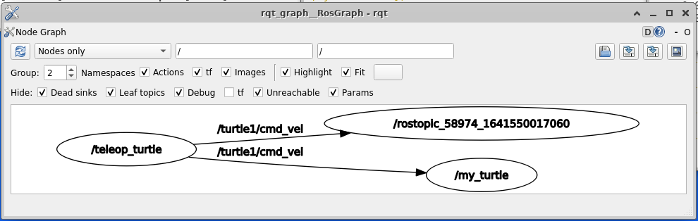

$ rostopic list -v

rostopic pub -1 /turtle1/cmd_vel geometry_msgs/Twist -- '[2.0, 0.0, 0.0]' '[0.0, 0.0, 1.8]'

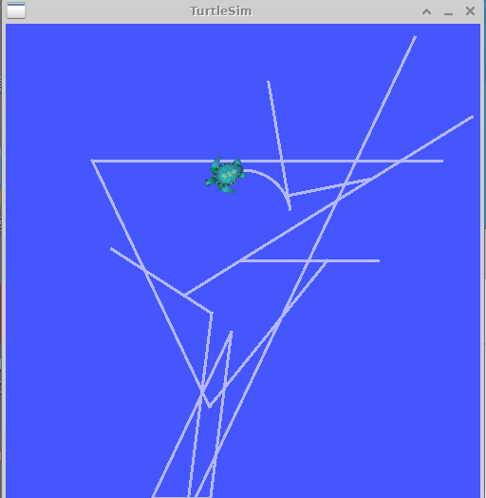

* $ rostopic pub /turtle1/cmd_vel geometry_msgs/Twist -r 1 -- '[2.0, 0.0, 0.0]' '[0.0, 0.0, -1.8]'

$ rosservice list

$ rosservice call /clear

$ rosservice type /spawn | rossrv show

$ rosservice call /spawn 2 2 0.2 ""

$ rosparam list

$ rosparam set /turtlesim/background_r 150

$ rosservice call /clear

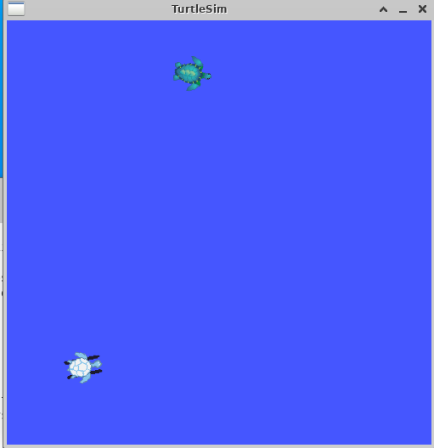

$ rosparam get /turtlesim/background_g

$ rosparam get /

### Using rqt_console and rqt_logger_level

$ rosrun rqt_console rqt_console

$ rosrun rqt_logger_level rqt_logger_level

$ rosrun turtlesim turtlesim_node

* rostopic pub /turtle1/cmd_vel geometry_msgs/Twist -r 1 -- '{linear: {x: 2.0, y: 0.0, z: 0.0}, angular: {x: 0.0,y: 0.0,z: 0.0}}'

### Using roslaunch

$ cd ~/catkin_ws

$ source devel/setup.bash

$ roscd beginner_tutorials

$ mkdir launch

$ cd launch

Now let's create a launch file called turtlemimic.launch and paste the following:

[切换行号显示](http://wiki.ros.org/ROS/Tutorials/UsingRqtconsoleRoslaunch)

<launch>

<group ns="turtlesim1">

<node pkg="turtlesim" name="sim" type="turtlesim_node"/>

</group>

<group ns="turtlesim2">

<node pkg="turtlesim" name="sim" type="turtlesim_node"/>

</group>

<node pkg="turtlesim" name="mimic" type="mimic">

<remap from="input" to="turtlesim1/turtle1"/>

<remap from="output" to="turtlesim2/turtle1"/>

</node>

</launch>

$ roslaunch beginner_tutorials turtlemimic.launch

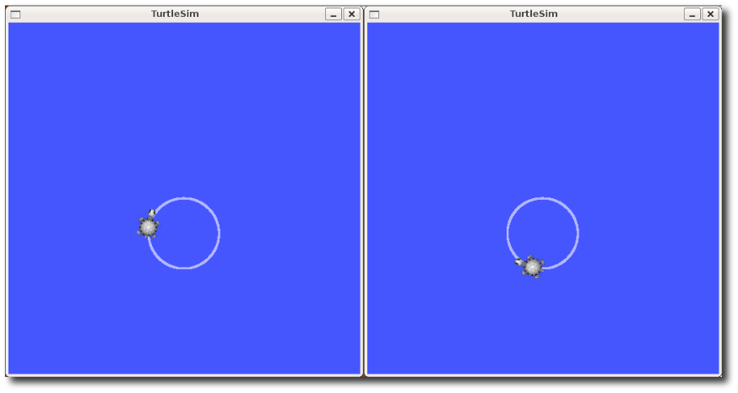

* $ rostopic pub /turtlesim1/turtle1/cmd_vel geometry_msgs/Twist -r 1 -- '[2.0, 0.0, 0.0]' '[0.0, 0.0, -1.8]'
* We can also use [rqt_graph](http://wiki.ros.org/rqt_graph) to better understand what our launch file did. Run [rqt](http://wiki.ros.org/rqt)'s main window and select Plugins > Introspection > Node Graph:
* $ rqt

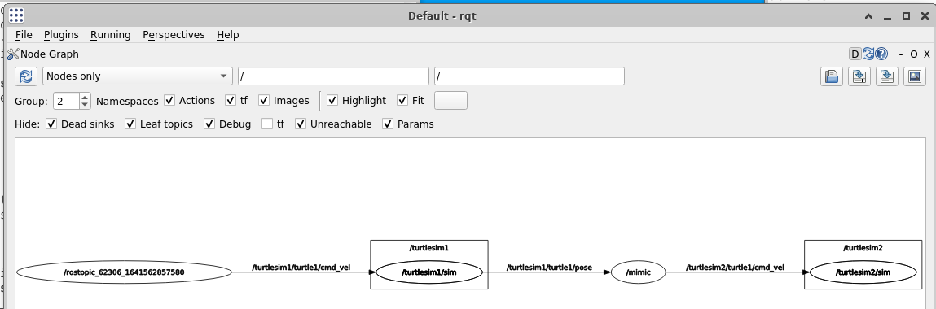

## kitti_tutorial

cd catkin_ws

source devel/setup.bash

roscore

cd catkin_ws/src

catkin_create_pkg kitti_tutorial rospy

cd ..

catkin_make

cd /home/Ubuntu/catkin_ws/src/kitti_tutorial/src

chmod +x kitti.py

rosrun kitti_tutorial kitti.py

rviz

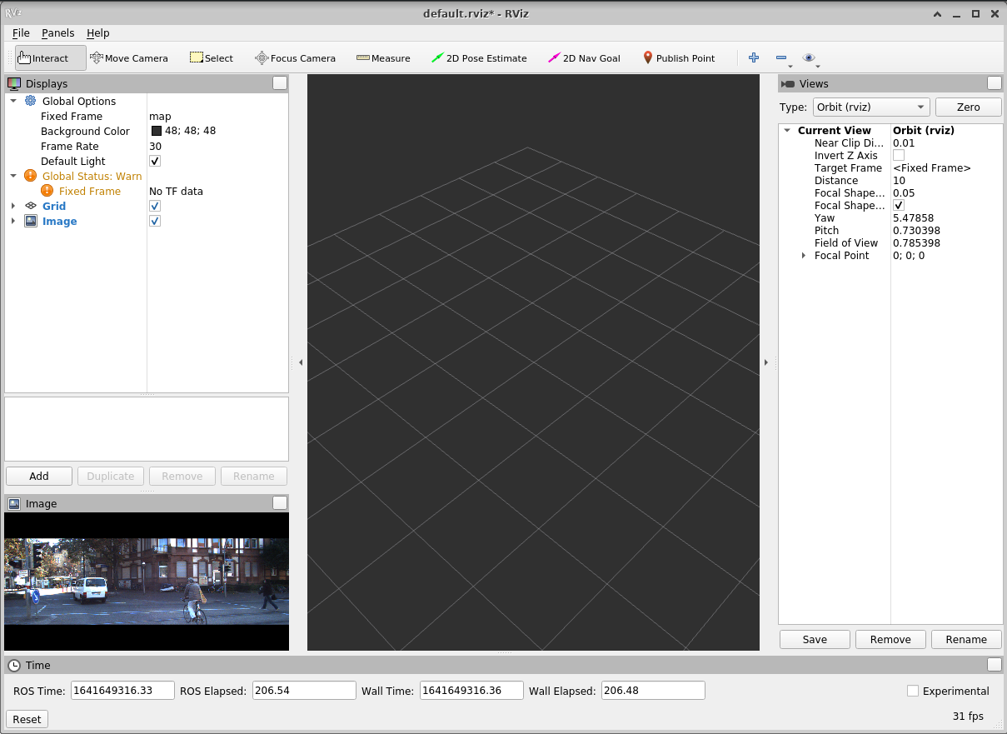

rostopic list

rostopic echo /kitti_gps

# pycharm中导入rospy包

在pycharm中

问题描述： import rospy 显示有错误，在终端中import rospy能通过，这种问题说明rospy已经安装成功，但是没有导入到pycharm中

解决办法：

1、依次点击File->settings->Project interpreter

2、点击上部选择框里的小箭头，选择show all

3、点击左下角5个图标中最右面一个图标（show paths for the selected interpreter）

4、点击左下角的加号，添加rospy的路径， 路径为/opt/ros/melodic/lib/python2.7/dist-packages/ 之后点击ok 就会发现pycharm中import rospy的报错信息消失了。

# C++

## 函数指针

int sum(int v1, int v2) {

return v1 + v2;

}

int main() {

cout << sum(10, 20) << endl;

int(*p)(int, int) = sum;

cout << p(10, 20) << endl;

getchar();

return 0;

}

## C++使用C来编译

extern "C" int sum(int v1, int v2) {

return v1 + v2;

}

extern "C" {

void func();

void func(int v);

}

C++使用汇编语言

__asm {

mov eax, 10

}

## 软件破解

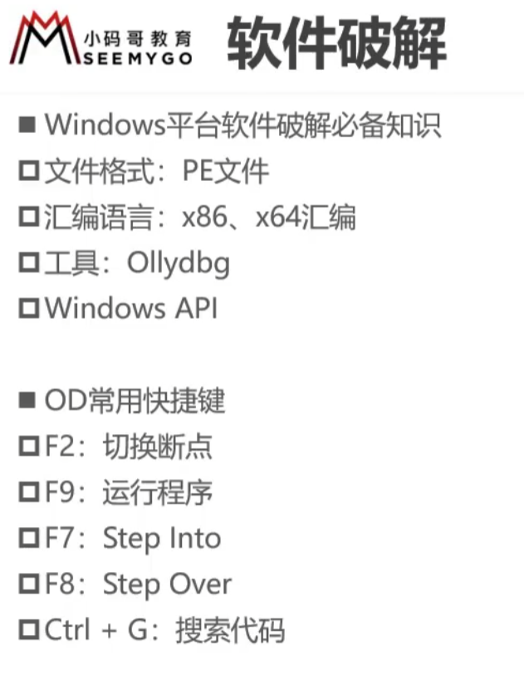

# 智能小车

## YOLOV5 训练自动驾驶数据集，并转成TENSORRT

https://www.freesion.com/article/61031371607/

## 无人驾驶系列入门与提高

### 车道线检测

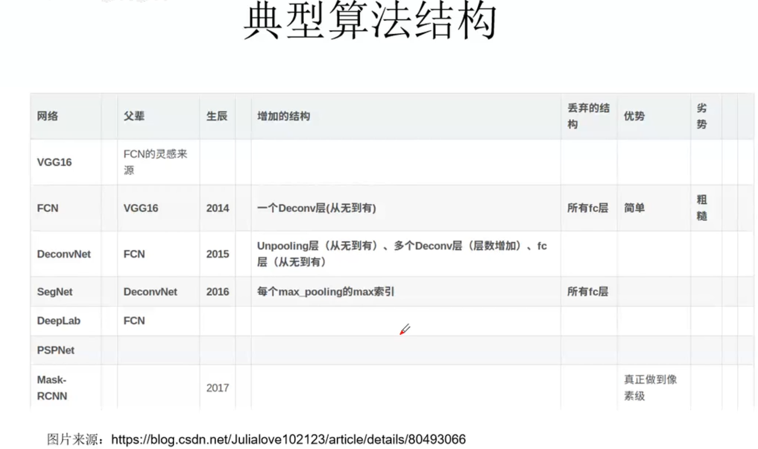

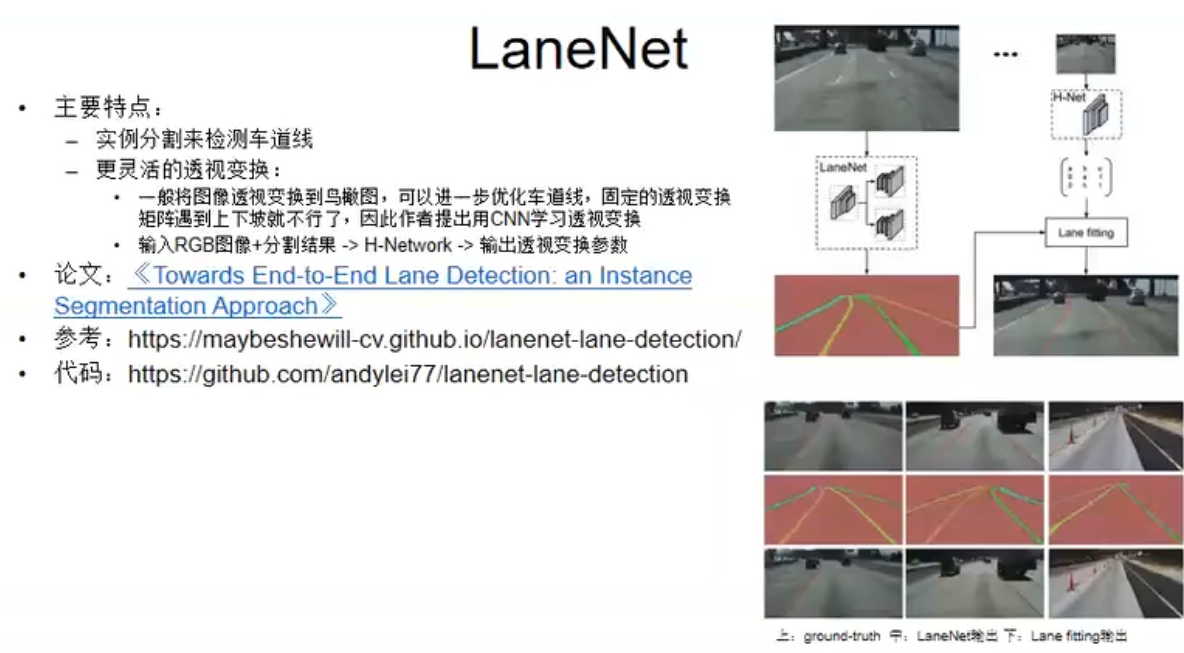

车道线检测论文汇总

<https://github.com/amusi/awesome-lane-detection>

### 目标检测

<https://github.com/hoya012/deep_learning_object_detection>

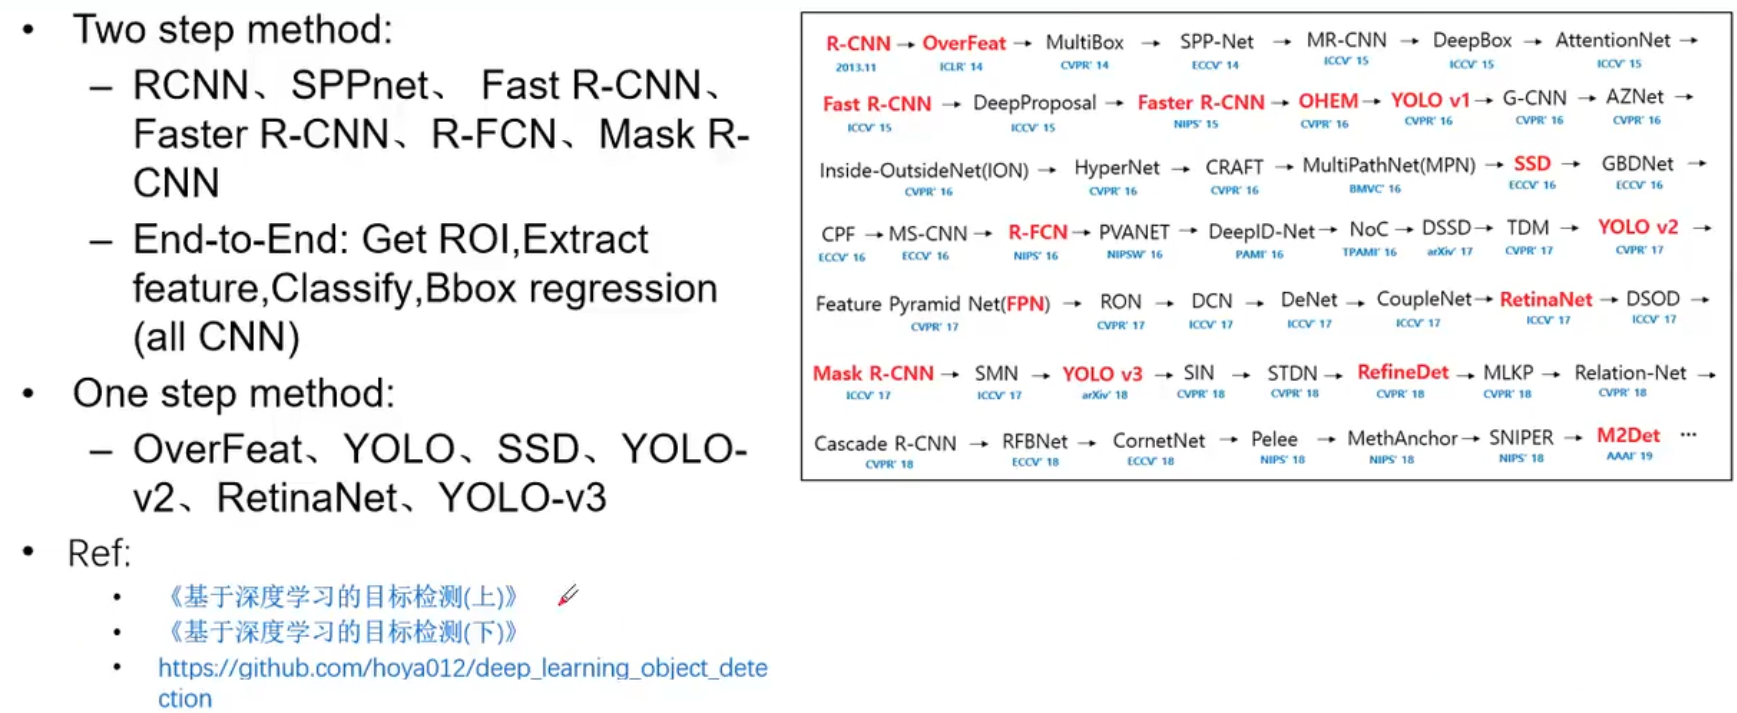

### 3D点云目标检测

鸟撖图和点云与图片叠加方法

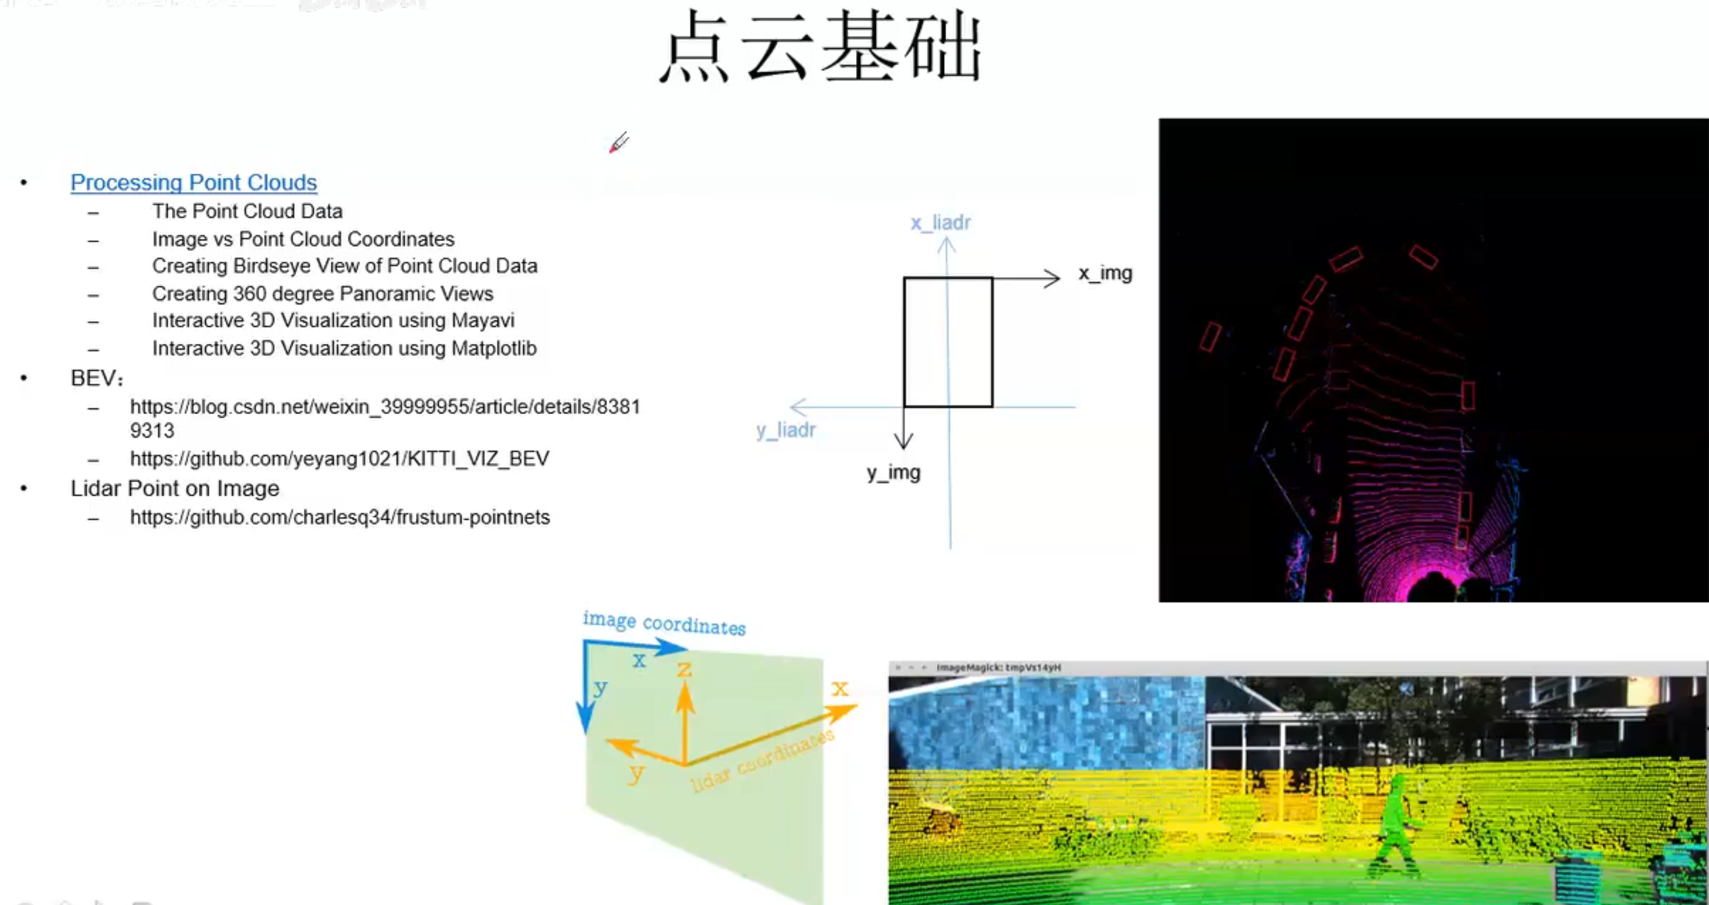

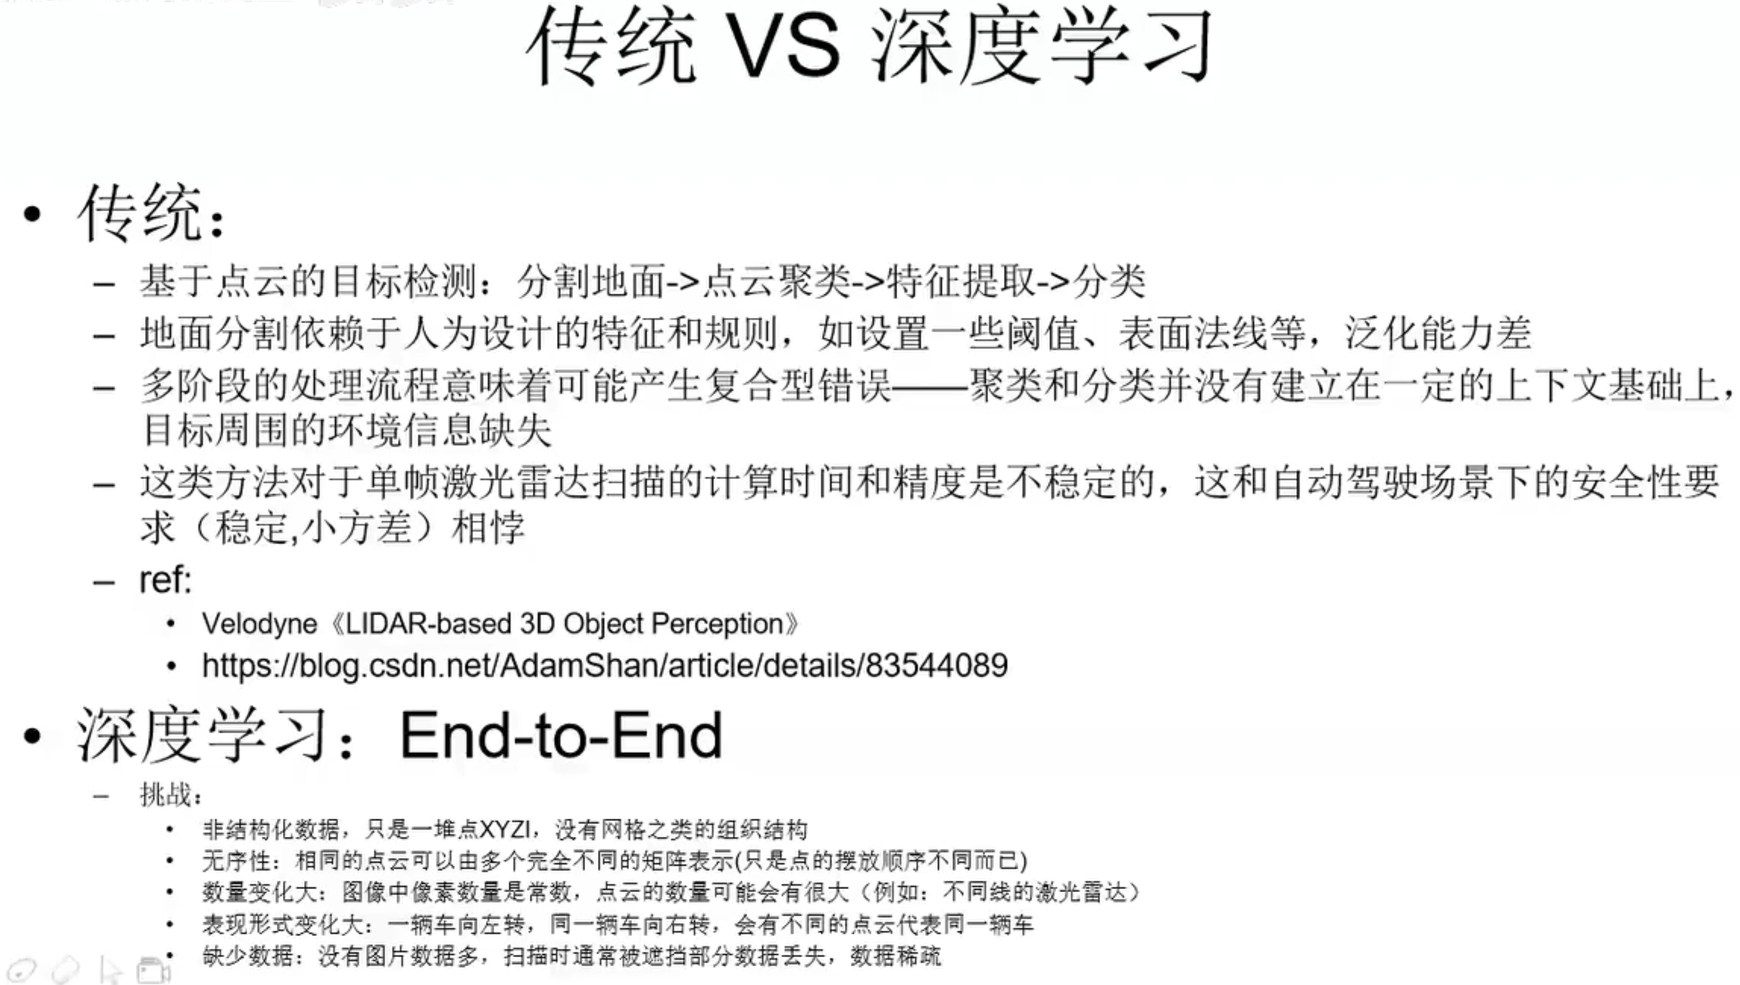

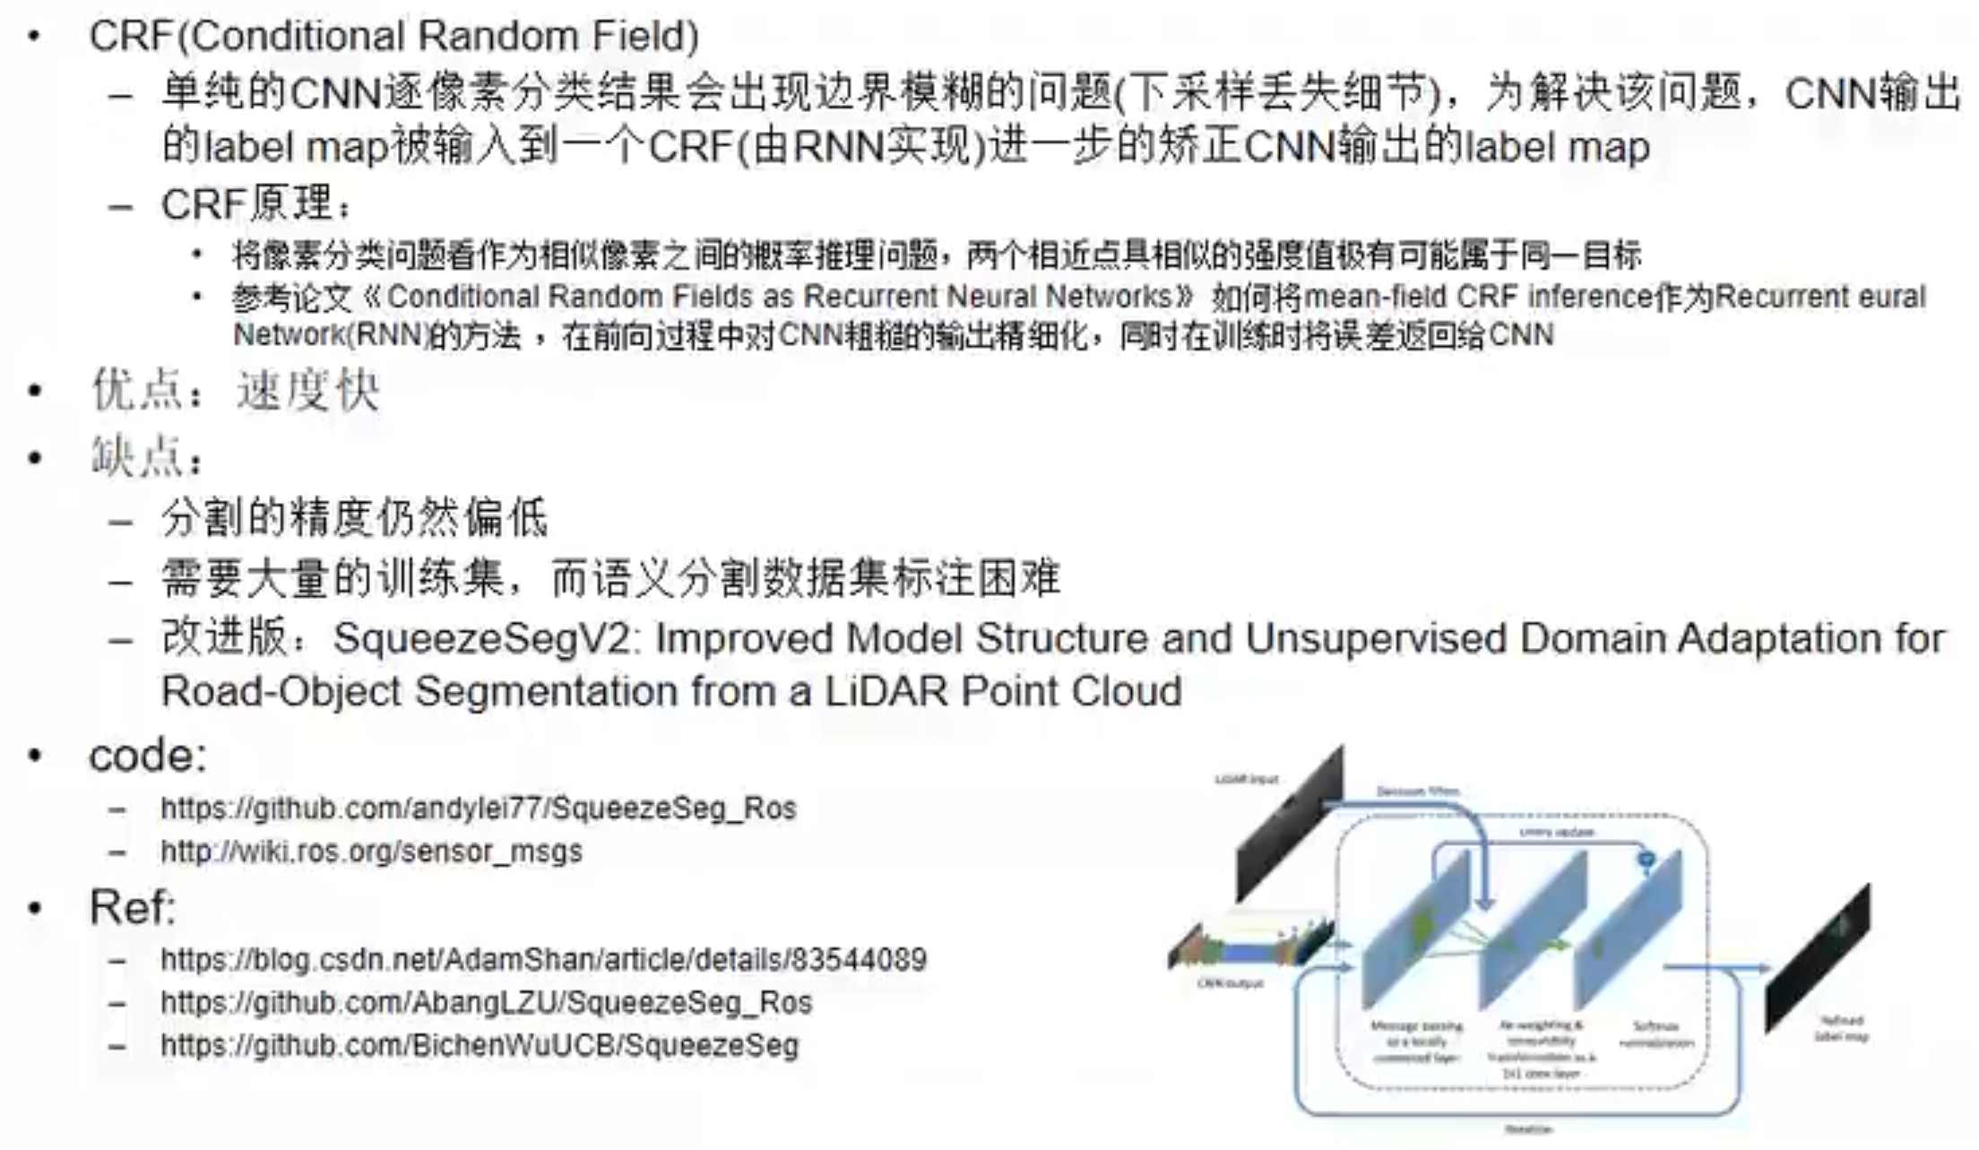

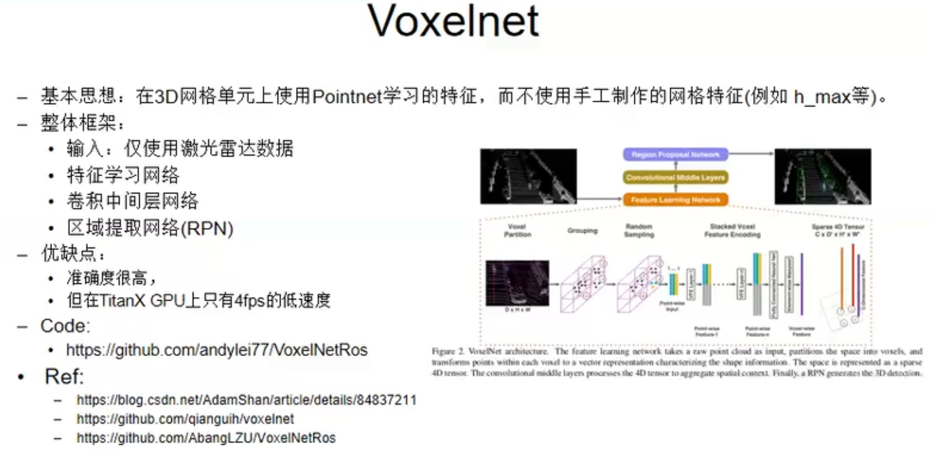

### 视觉定位

卡尔曼滤波

<https://github.com/andylei77/kalman_particle_demo>

### 建图

激光点云+camera

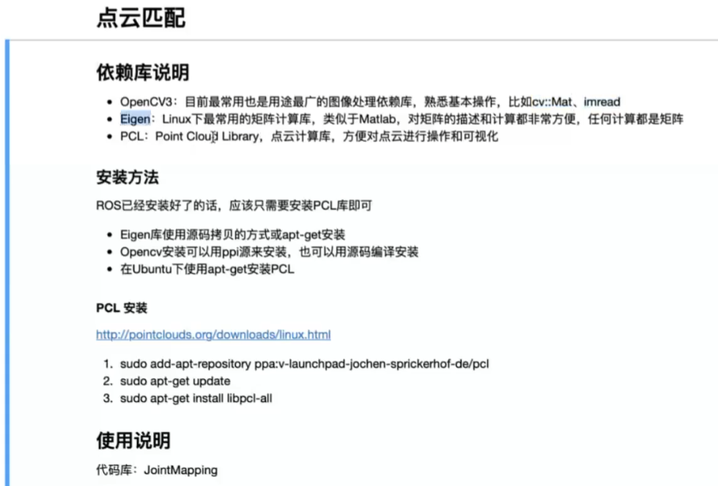

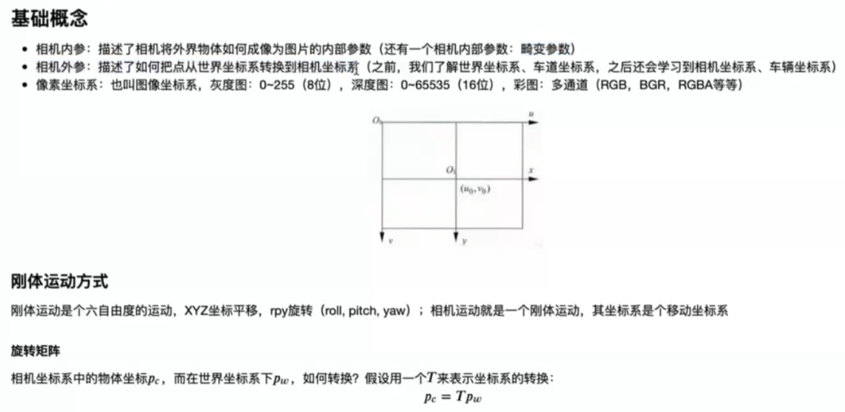

### 无人车定位系统

https://gitee.com/paopaoslam/ORB-SLAM2

<https://github.com/raulmur/ORB_SLAM2>

### 预测系统

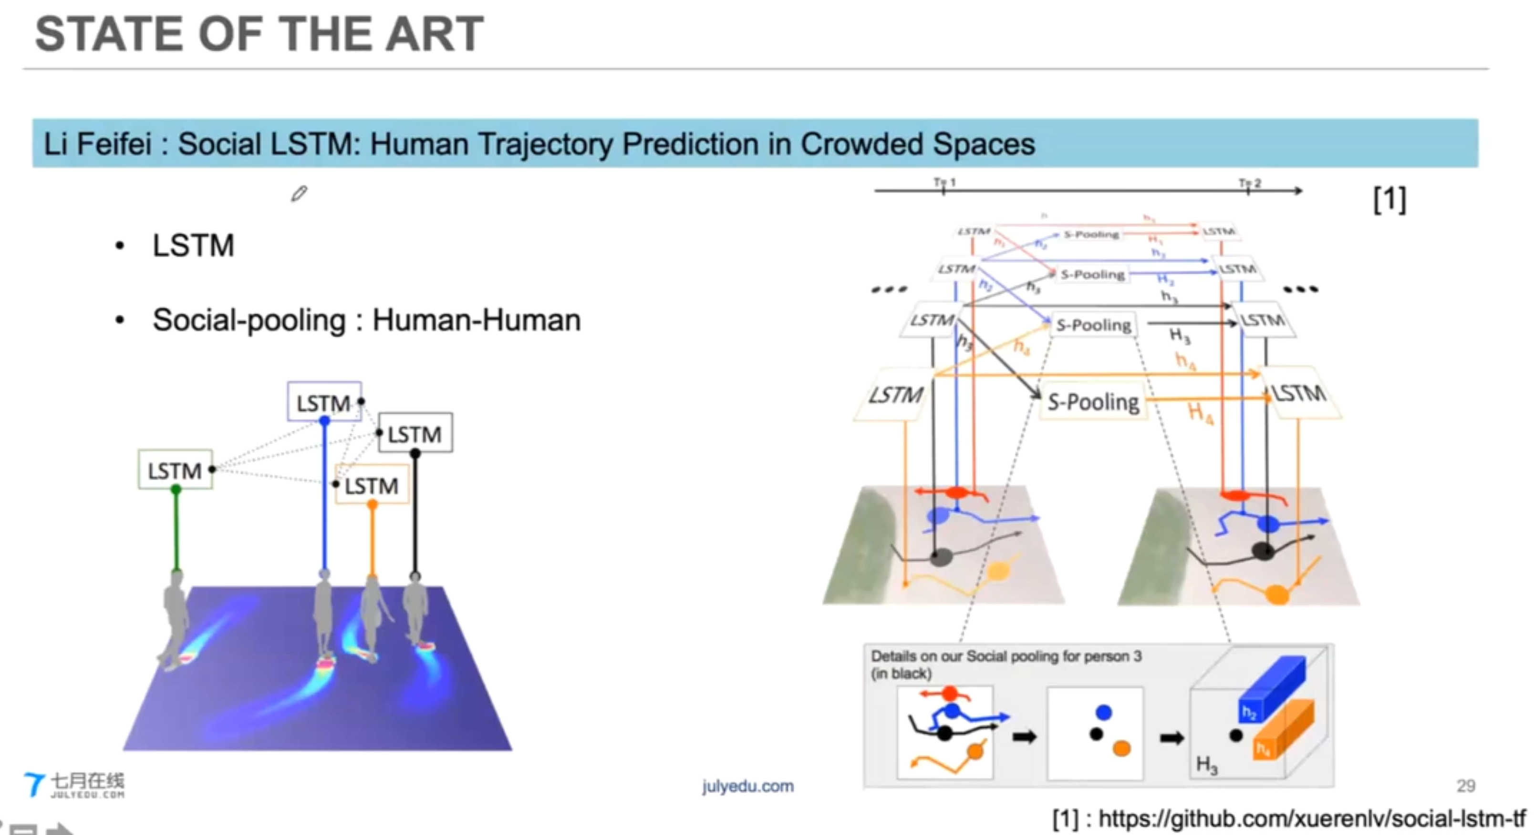

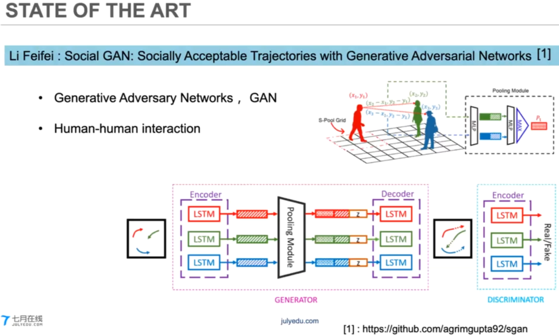

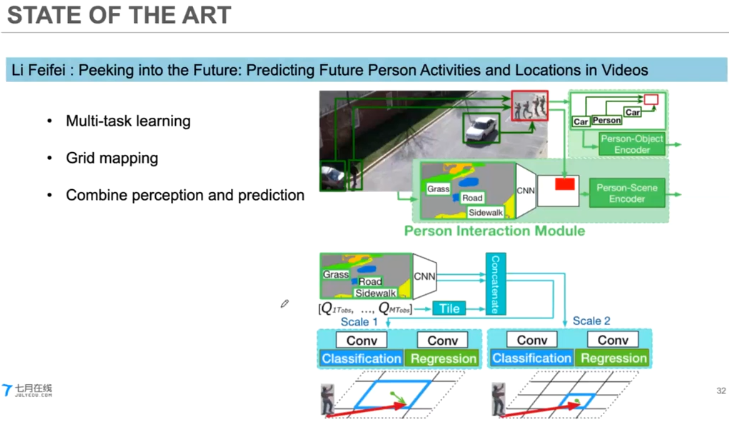

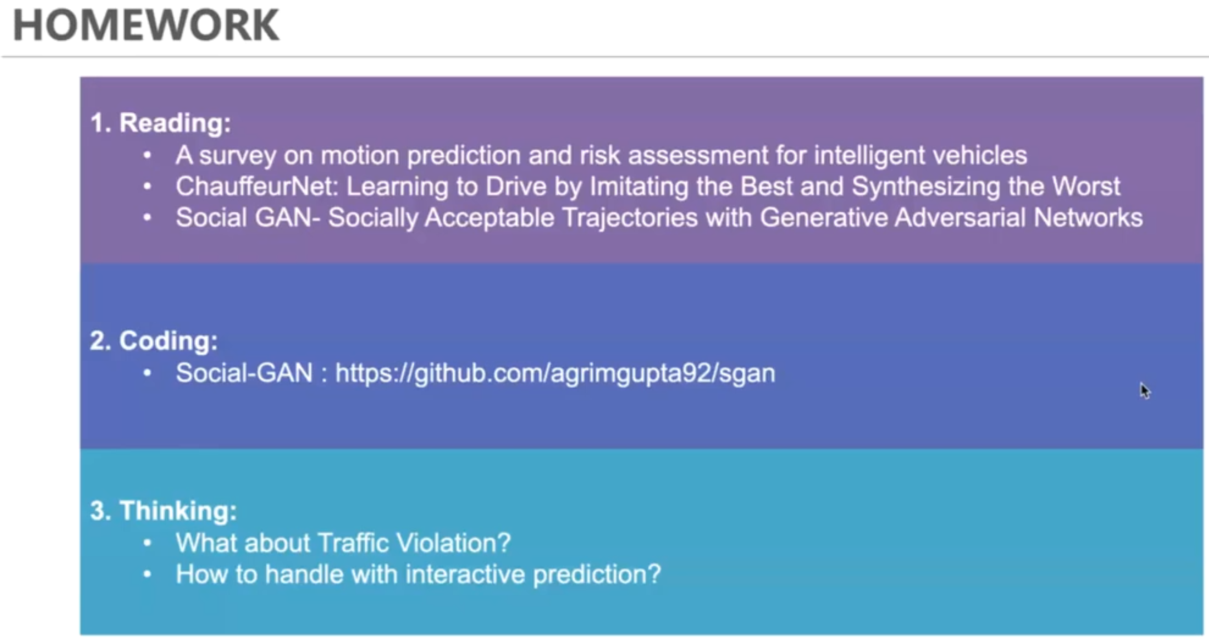

### 路径规划

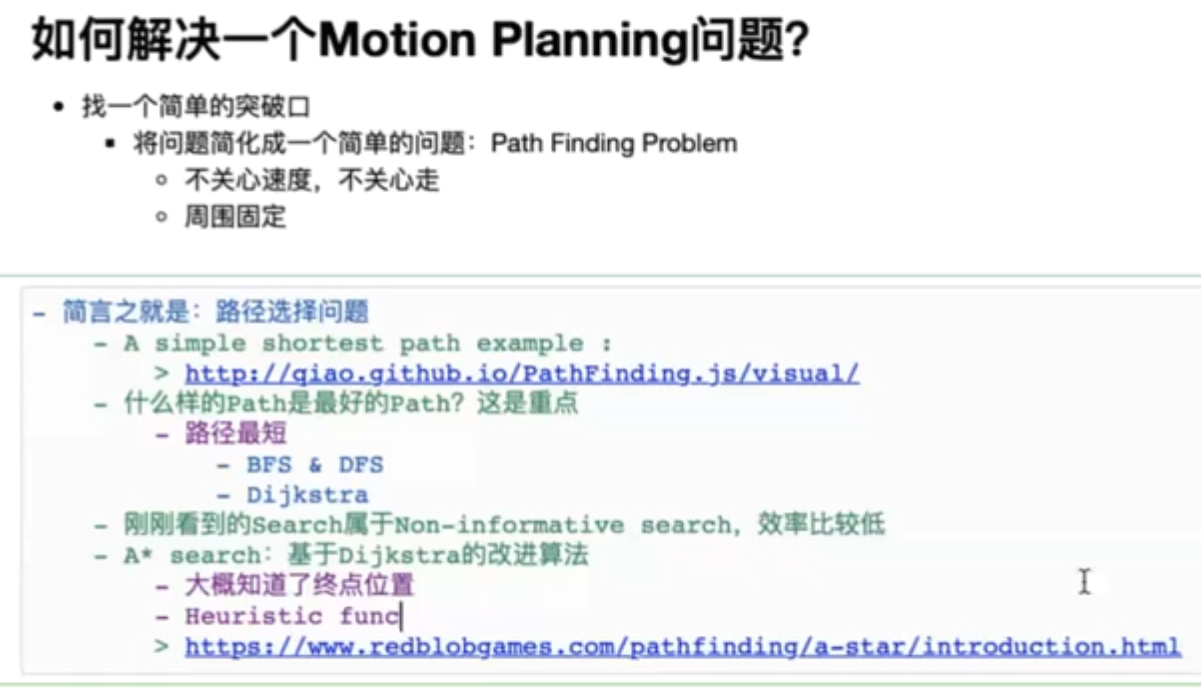

D* Search

D* Lite Search

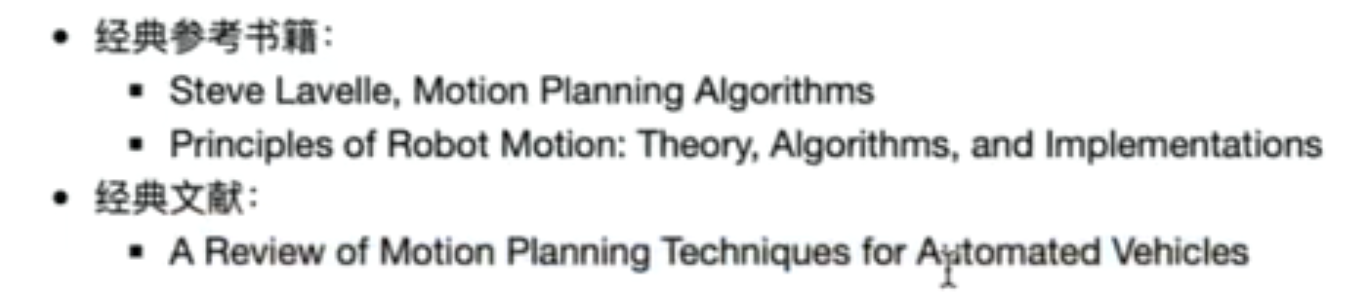

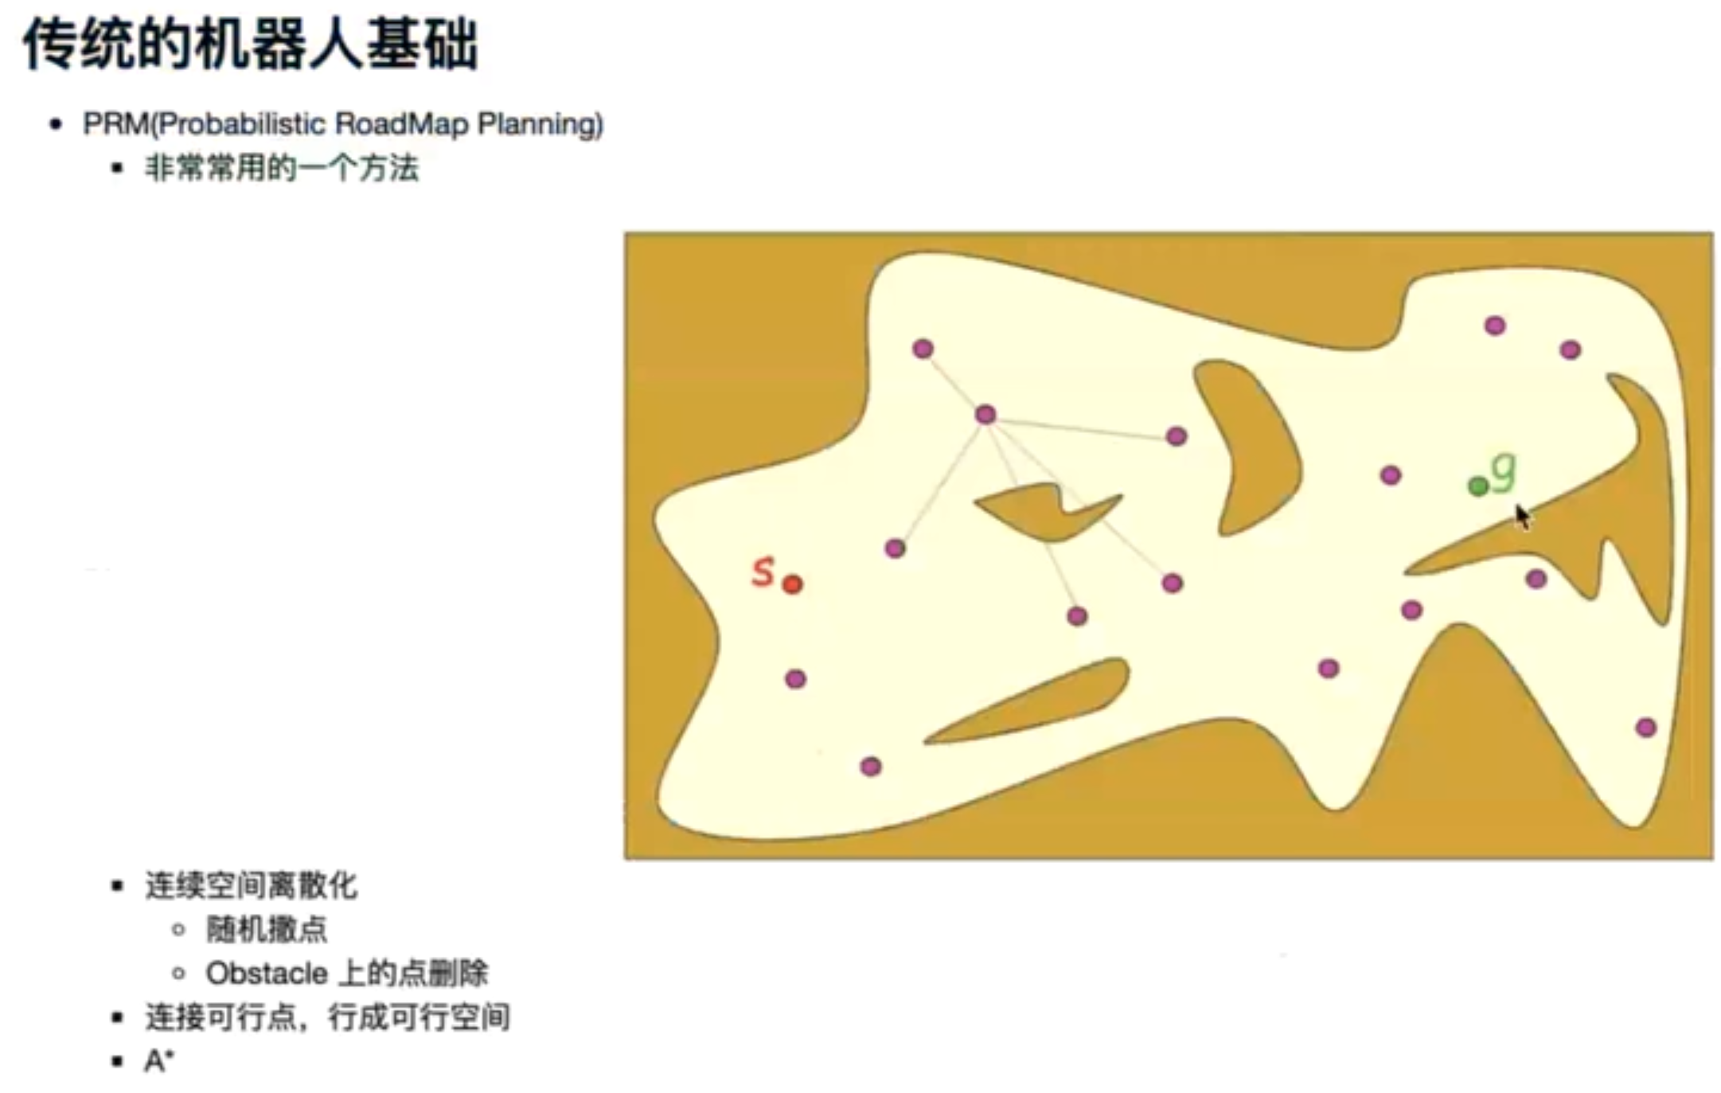

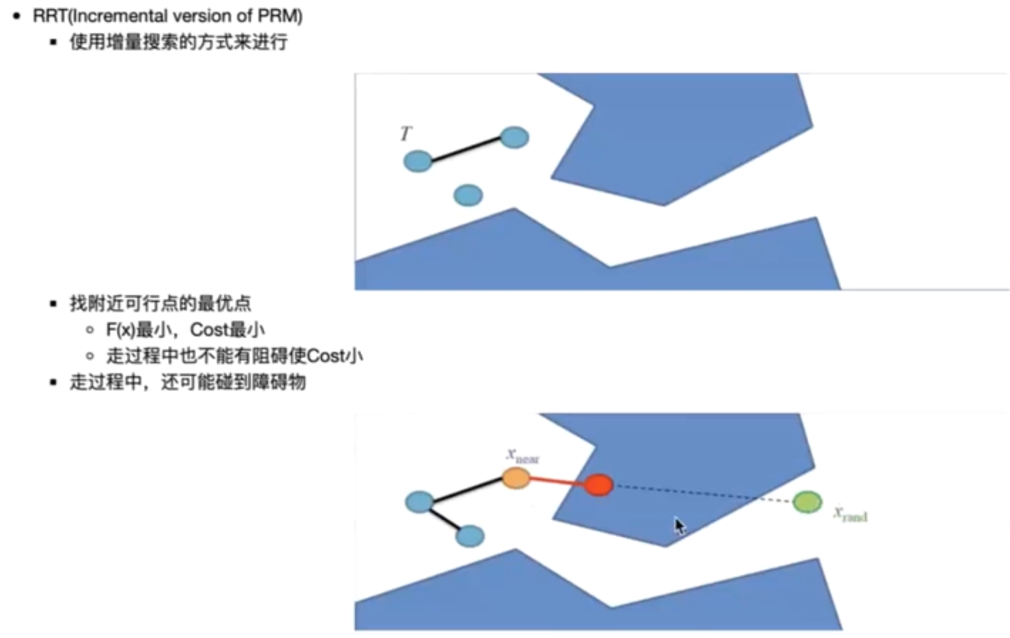



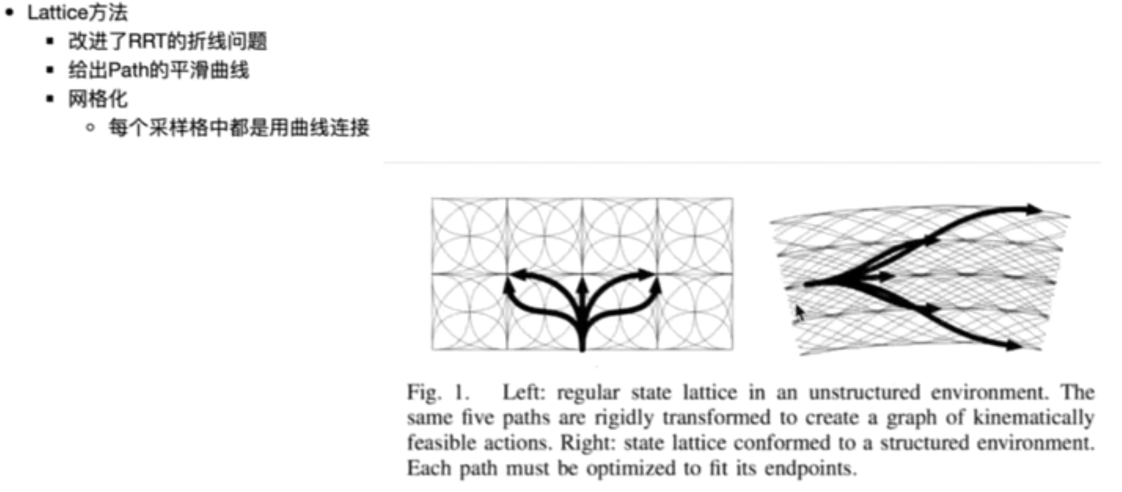

指数级别的一个搜索算法（NP-Hard）

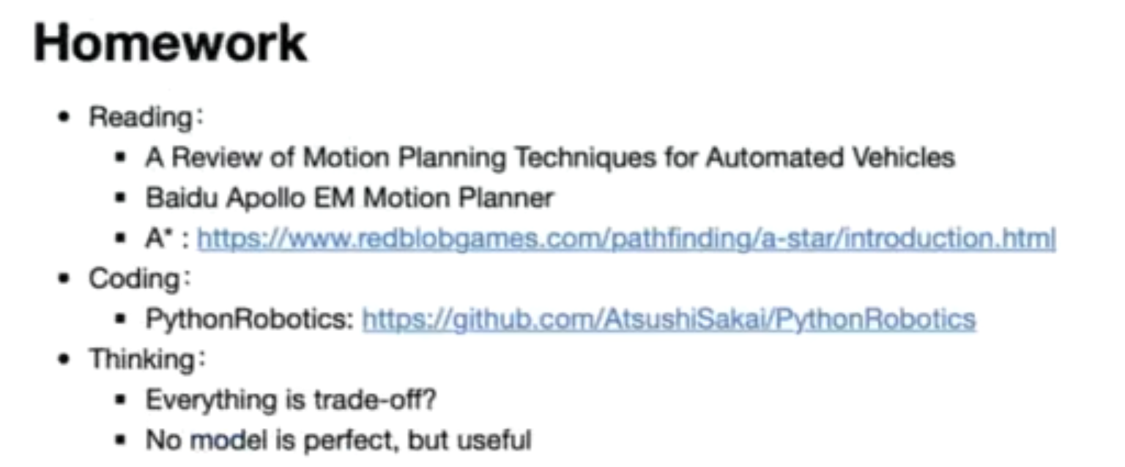

### 控制理论

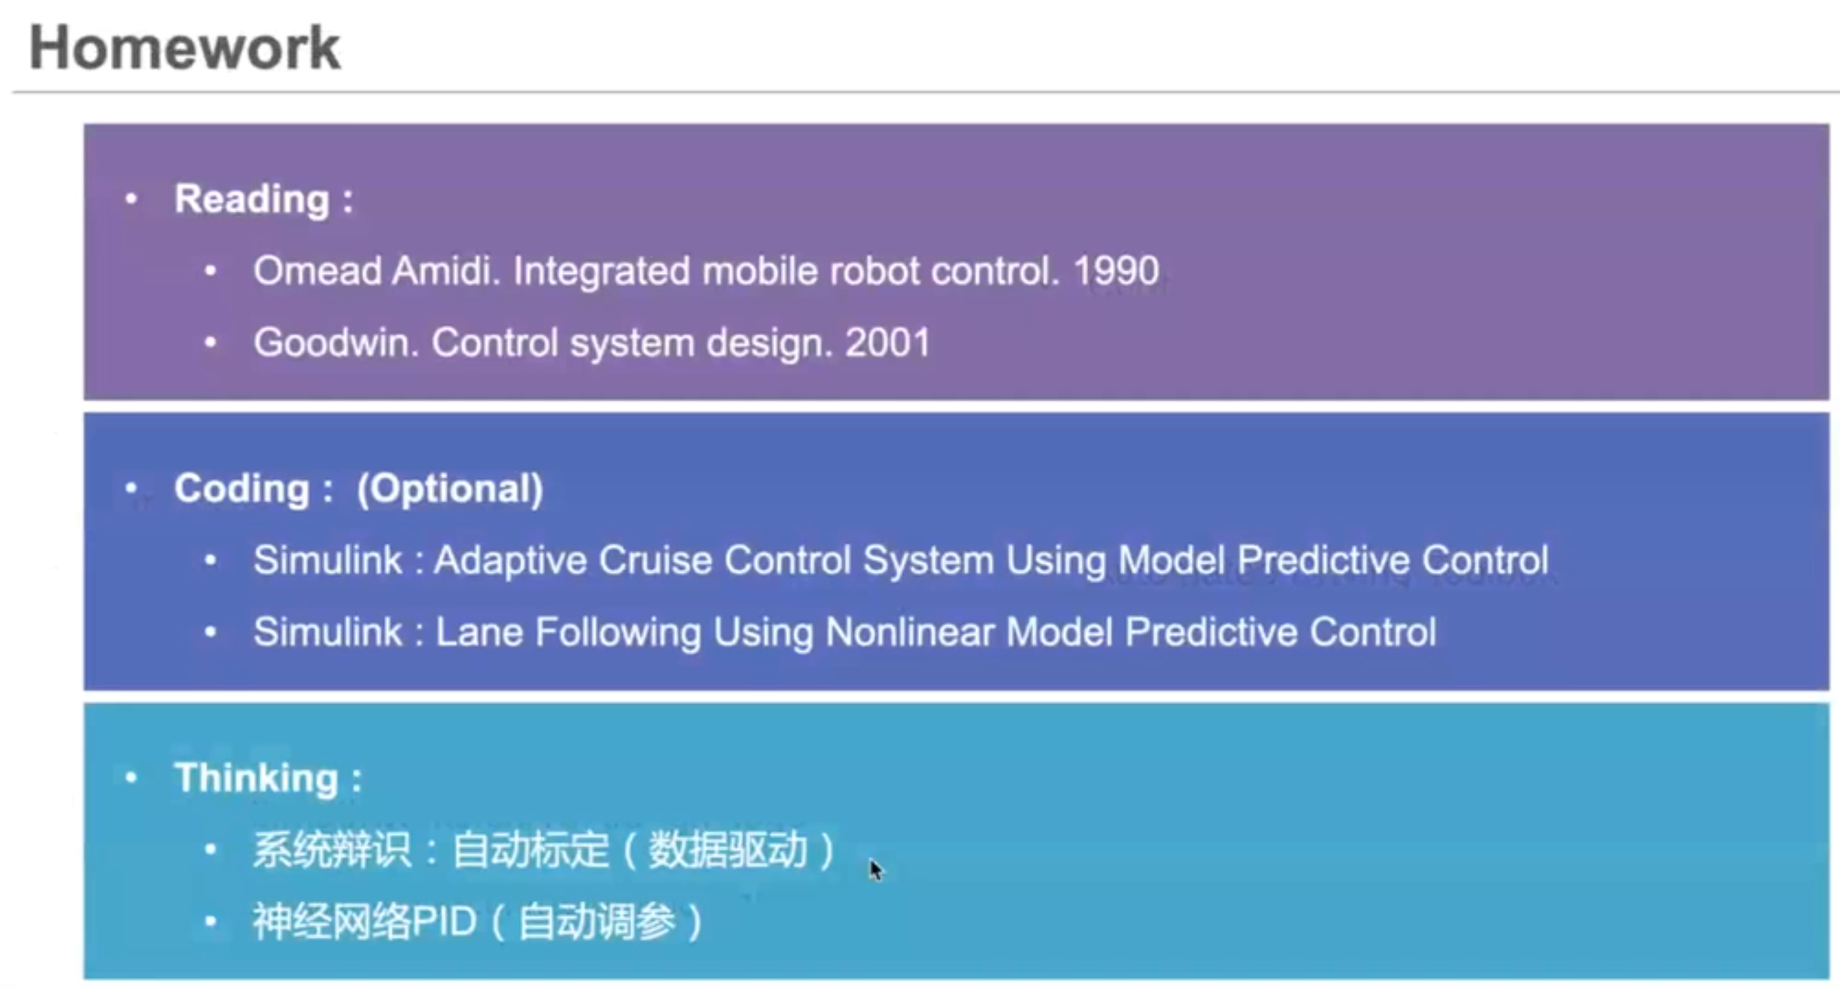

### 强化学习

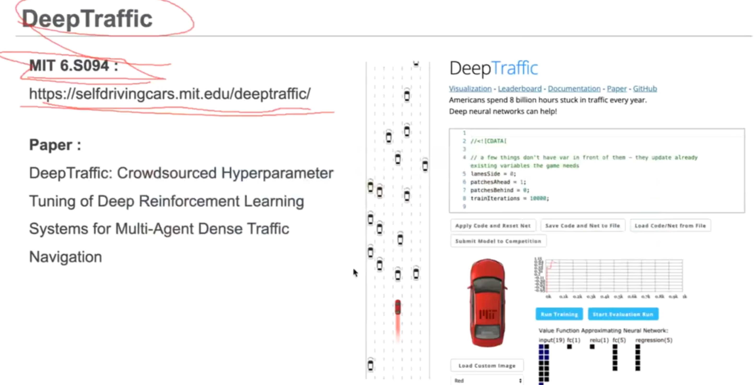

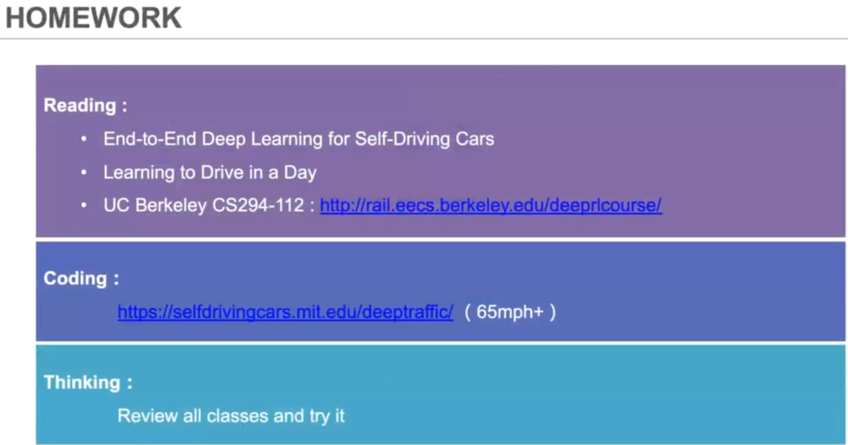

## ROS小车

ROS虚拟机镜像

链接：https://pan.baidu.com/s/1twemB6iLbWMRhLQg5WQWeQ

提取码：ptp9

账户：passoni

密码：raspberry

修改root密码

sudo passwd root

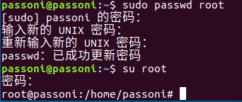

虚拟机ubuntu配置静态ip地址

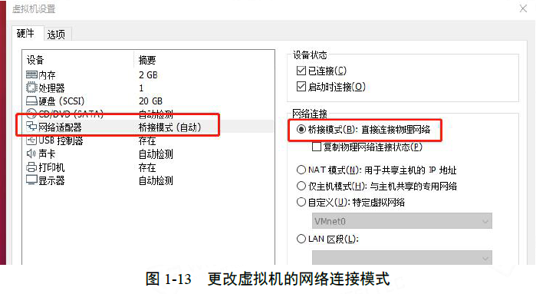

点击VMware左上角编辑->虚拟网络编辑器->更改设置

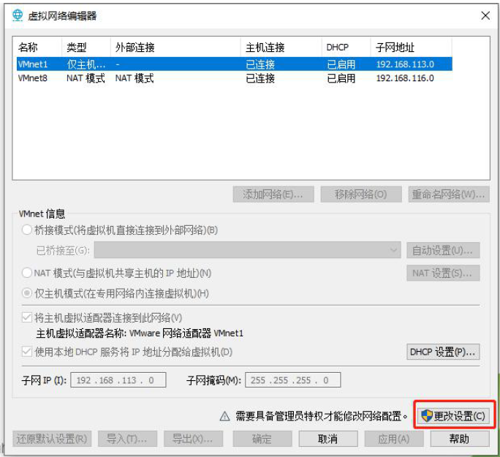

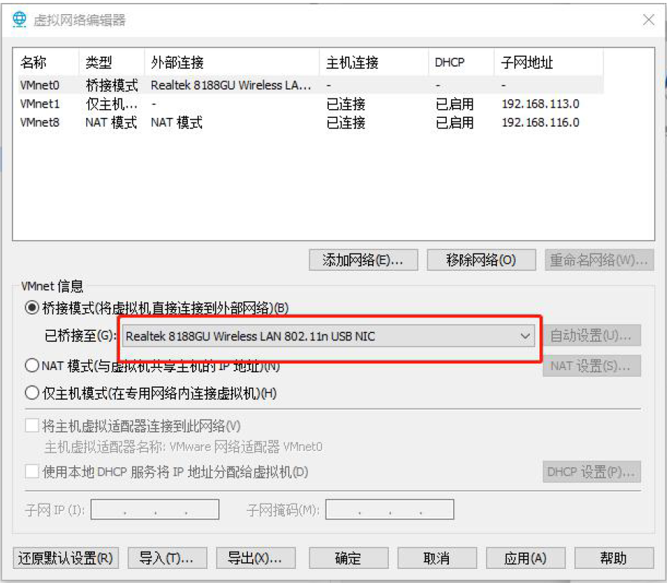

进入ubuntu系统，在右上角，找到网络按钮

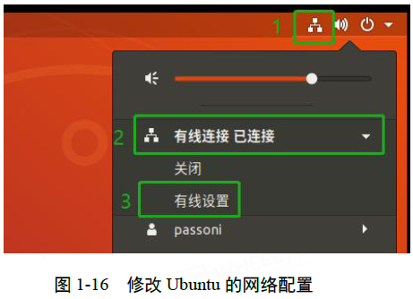

添加+，配置名称为Static IP

ipv4: 192.168.0.136

默认路由: 192.168.0.1

DNS: 192.168.0.136

## vmware中ubuntu虚拟机扩容

两种扩容方式：

重新创建一块虚拟硬盘

扩大原来的硬盘：如果装系统时没有进行手动分区，系统只有两个分区（根分区和交换分区），这种情况我们直接扩展根分区的大小。

我们是为了解决当前用户空间不够的问题，所以我们要给当前用户的目录所挂载的硬盘扩容（不进行文件复制），所以我们选择第二种扩容方式，步骤如下：

1.扩展虚拟机硬盘大小（关机状态才能扩容）

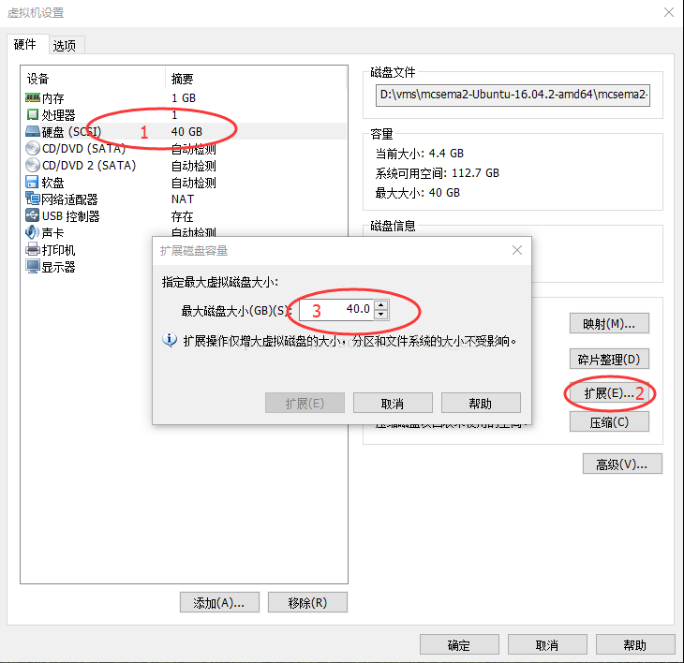

2.安装修改文件大小的软件，此软件和Window上的DiskGenius用法相似。

sudo apt-get install gparted

搜索打开gparted

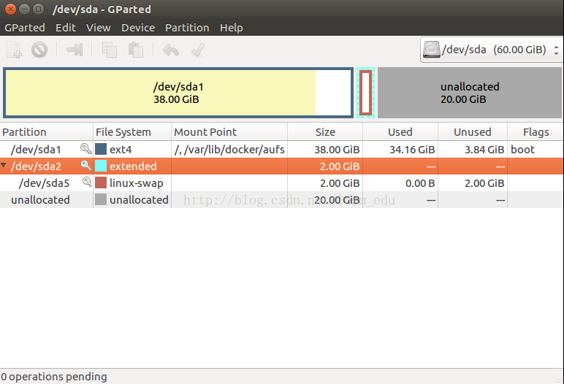

3.和DiskGenius相同，只有相邻的空间时没有被分配的才能扩展空间大小，所以我们先删除/dev/sda2，保存修改（点击变成绿色的对号）。

4./dev/sda1之后的空间都是未分配的空间，我们可以把鼠标放在/dev/sda1，右键

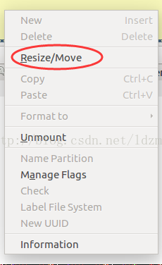

鼠标拖动改变大小，或者直接在New size对应的文本框输入大小。预留部分空间给我们在第三步删除的交换分区。

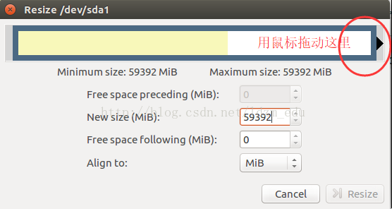

5.鼠标放在剩余的未分配的空间，创建交换分区，保存修改。

6.sudo fdisk -l，/dev/sda1空间从40G扩展到了58G

## 左手和右手坐标系

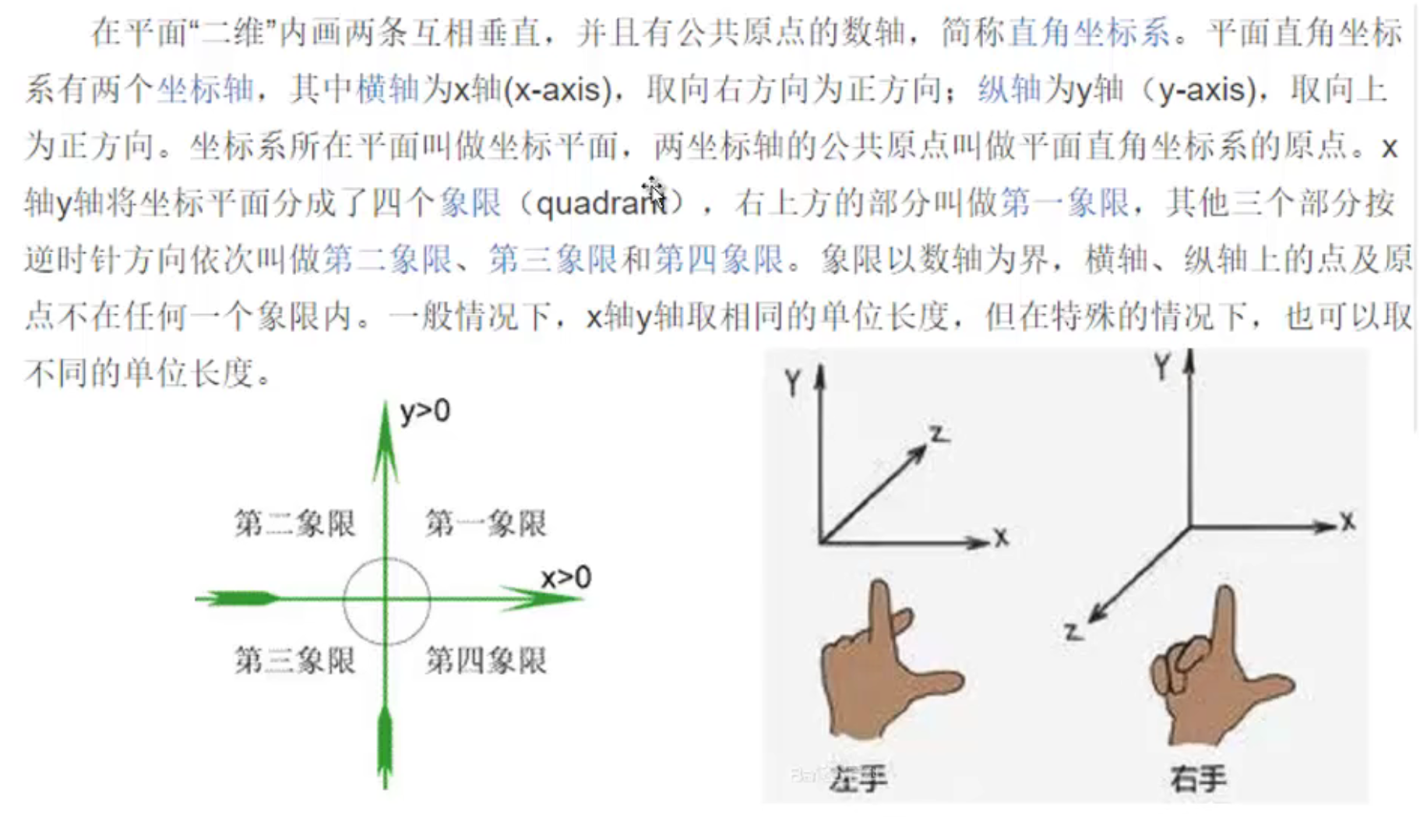

## 小孔成像坐标系

物距u，像距v，焦距f，

当u>v且u>2f时，f<v<2f，成倒立缩小实像，照相机的运用

当u<v且f<u<2f时，v>2f，成倒立放大实像，投影仪的运用

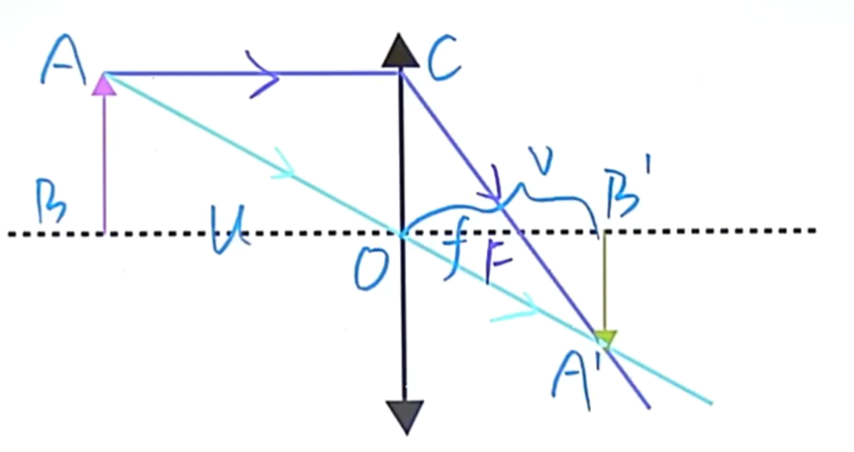

立体视觉中将像距v等同于焦距f

